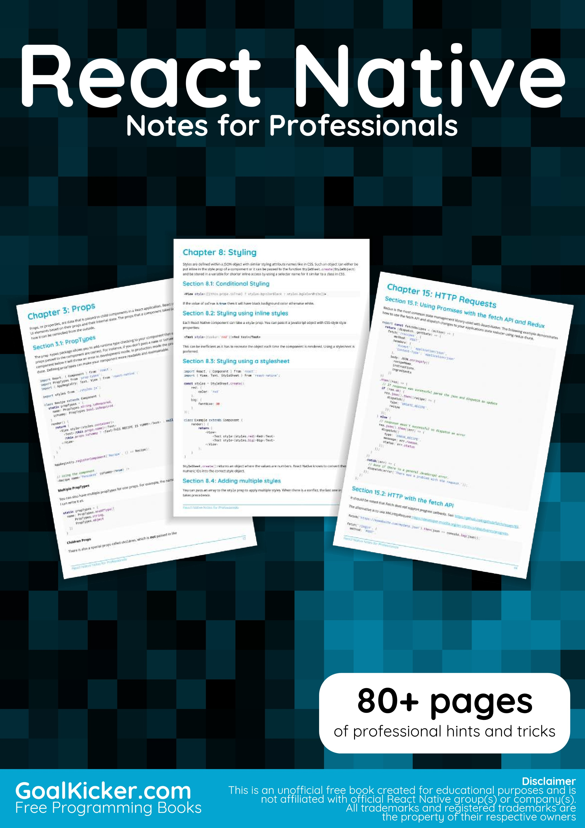

**Contents**

**About** 1

**Chapter 1: Getting started with React Native** 1

Section 1.1: Setup for Mac 1

Section 1.2: Setup for Linux (Ubuntu) 7

Section 1.3: Setup for Windows 9

**Chapter 2: Hello World** 11

Section 2.1: Editing index.ios.js or index.android.js 11

Section 2.2: Hello world! 11

**Chapter 3: Props** 12

Section 3.1: PropTypes 12

Section 3.2: What are props? 13

Section 3.3: Use of props 13

Section 3.4: Default Props 14

**Chapter 4: Multiple props rendering** 15

Section 4.1: render multiple variables 15

**Chapter 5: Modal** 16

Section 5.1: Modal Basic Example 17

Section 5.2: Transparent Modal Example 18

**Chapter 6: State** 20

Section 6.1: setState 20

Section 6.2: Initialize State 22

**Chapter 7: Routing** 23

Section 7.1: Navigator component 23

**Chapter 8: Styling** 23

Section 8.1: Conditional Styling 23

Section 8.2: Styling using inline styles 23

Section 8.3: Styling using a stylesheet 24

Section 8.4: Adding multiple styles 24

**Chapter 9: Layout** 26

Section 9.1: Flexbox 26

**Chapter 10: Components** 35

Section 10.1: Basic Component 35

Section 10.2: Stateful Component 35

Section 10.3: Stateless Component 35

**Chapter 11: ListView** 37

Section 11.1: Simple Example 37

**Chapter 12: RefreshControl with ListView** 37

Section 12.1: Refresh Control with ListView Full Example 37

Section 12.2: Refresh Control 39

Section 12.3: onRefresh function Example 40

**Chapter 13: WebView** 41

Section 13.1: Simple component using webview 41

**Chapter 14: Command Line Instructions** 42

Section 14.1: Check version installed 42

Section 14.2: Initialize and getting started with React Native project 42

Section 14.3: Upgrade existing project to latest RN version 42

Section 14.4: Add android project for your app 42

Section 14.5: Logging 42

Section 14.6: Start React Native Packager 43

**Chapter 15: HTTP Requests** 44

Section 15.1: Using Promises with the fetch API and Redux 44

Section 15.2: HTTP with the fetch API 44

Section 15.3: Networking with XMLHttpRequest 45

Section 15.4: WebSockets 45

Section 15.5: Http with axios 45

Section 15.6: Web Socket with Socket.io 47

**Chapter 16: Platform Module** 48

Section 16.1: Find the OS Type/Version 48

**Chapter 17: Images** 48

Section 17.1: Image Module 48

Section 17.2: Image Example 49

Section 17.3: Conditional Image Source 49

Section 17.4: Using variable for image path 49

Section 17.5: To fit an Image 49

**Chapter 18: Custom Fonts** 50

Section 18.1: Custom fonts for both Android and IOS 50

Section 18.2: Steps to use custom fonts in React Native (Android) 51

Section 18.3: Steps to use custom fonts in React Native (iOS) 51

**Chapter 19: Animation API** 54

Section 19.1: Animate an Image 54

**Chapter 20: Android - Hardware Back Button** 55

Section 20.1: Detect Hardware back button presses in Android 55

Section 20.2: Example of BackAndroid along with Navigator 55

Section 20.3: Hardware back button handling using BackHandler and Navigation Properties (without 56

using deprecated BackAndroid & deprecated Navigator) 56

Section 20.4: Example of Hardware back button detection using BackHandler 57

**Chapter 21: Run an app on device (Android Version)** 58

Section 21.1: Running an app on Android Device 58

**Chapter 22: Native Modules** 59

Section 22.1: Create your Native Module (IOS) 59

**Chapter 23: Linking Native API** 61

Section 23.1: Outgoing Links 61

Section 23.2: Incomming Links 61

**Chapter 24: ESLint in React Native** 63

Section 24.1: How to start 63

**Chapter 25: Integration with Firebase for Authentication** 64

Section 25.1: Authentication In React Native Using Firebase 64

Section 25.2: React Native - ListView with Firebase 64

**Chapter 26: Navigator Best Practices** 67

Section 26.1: Navigator 67

Section 26.2: Use react-navigation for navigation in react native apps 69

Section 26.3: react-native Navigation with react-native-router-flux 70

**Chapter 27: Navigator with buttons injected from pages** 72

Section 27.1: Introduction 72

Section 27.2: Full commented example 73

**Chapter 28: Create a shareable APK for android** 76

Section 28.1: Create a key to sign the APK 76

Section 28.2: Once the key is generated, use it to generate the installable build: 76

Section 28.3: Generate the build using gradle 76

Section 28.4: Upload or share the generated APK 76

**Chapter 29: PushNotification** 76

Section 29.1: Push Notification Simple Setup 76

Section 29.2: Navigating to scene from Notification 79

**Chapter 30: Render Best Practises** 81

Section 30.1: Functions in JSX 81

**Chapter 31: Debugging** 82

Section 31.1: Start Remote JS Debugging in Android 82

Section 31.2: Using console.log() 82

**Chapter 32: Unit Testing** 83

Section 32.1: Unit Test In React Native Using Jest 83

**Credits** 84

**You may also like** 86

# About

Please feel free to share this PDF with anyone for free, latest version of this book can be downloaded from:

<https://goalkicker.com/ReactNativeBook>

This *React Native Notes for Professionals* book is compiled from [Stack Overflow](https://archive.org/details/documentation-dump.7z)

[Documentation](https://archive.org/details/documentation-dump.7z), the content is written by the beautiful people at Stack Overflow.

Text content is released under Creative Commons BY-SA, see credits at the end of this book whom contributed to the various chapters. Images may be copyright of their respective owners unless otherwise specified

This is an unofficial free book created for educational purposes and is not affiliated with official React Native group(s) or company(s) nor Stack Overflow. All trademarks and registered trademarks are the property of their respective company owners

The information presented in this book is not guaranteed to be correct nor accurate, use at your own risk

Please send feedback and corrections to web@petercv.com

# Chapter 1: Getting started with React Native

## Section 1.1: Setup for Mac

**Installing package manager Homebrew brew** Paste that at a Terminal prompt.

**/**usr**/**bin**/**ruby **-**e "$(curl -fsSL https://raw.githubusercontent.com/Homebrew/install/master/install)"

**Installing Xcode IDE**

Download it using link below or find it on Mac App Store <https://developer.apple.com/download/>

**NOTE:** If you have **Xcode-beta.app** installed along with production version of **Xcode.app**, make sure you are using production version of xcodebuild tool. You can set it with:

**sudo** xcode-select -switch **/**Applications**/**Xcode.app**/**Contents**/**Developer**/**

**Installing Android environment**

Git **git**

*If you have installed XCode, Git is already installed, otherwise run the following

brew install git

Latest JD

[K](http://www.oracle.com/technetwork/java/javase/downloads/jdk8-downloads-2133151.html)

Android Studi

[o](http://developer.android.com/sdk/index.html)

Choose a Custom installation

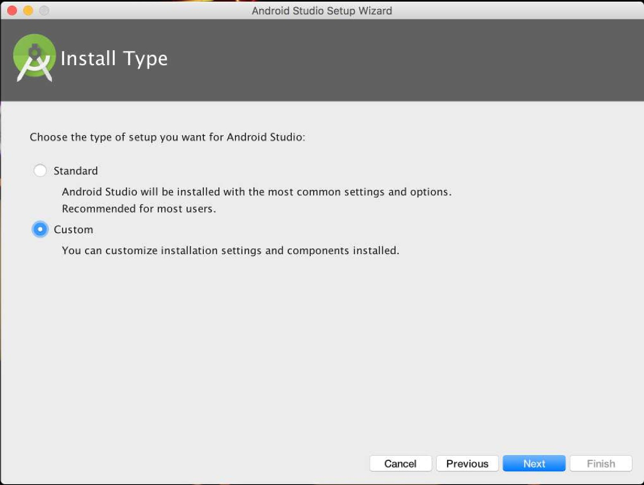

Choose both Performance and Android Virtual Device

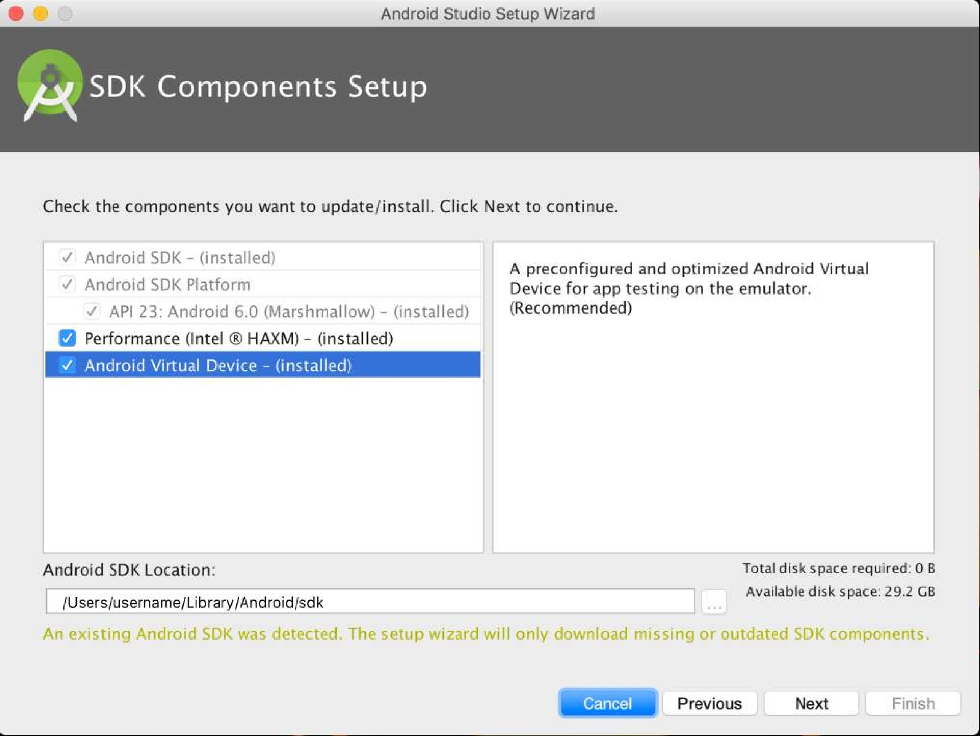

After installation, choose Configure -> SDK Manager from the Android Studio welcome window.

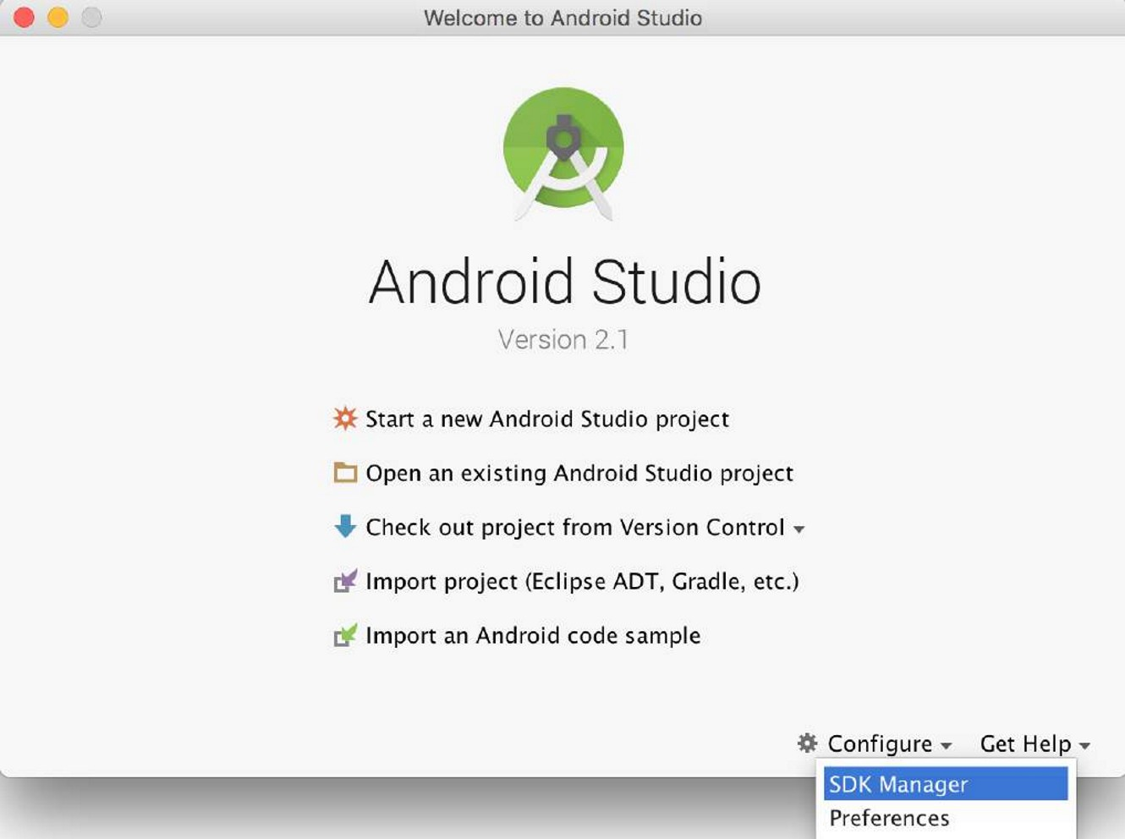

In the SDK Platforms window, choose Show Package Details and under Android 6.0 (Marshmallow), make sure that Google APIs, Intel x86 Atom System Image, Intel x86 Atom_64 System Image, and Google APIs Intel x86 Atom_64 System Image are checked.

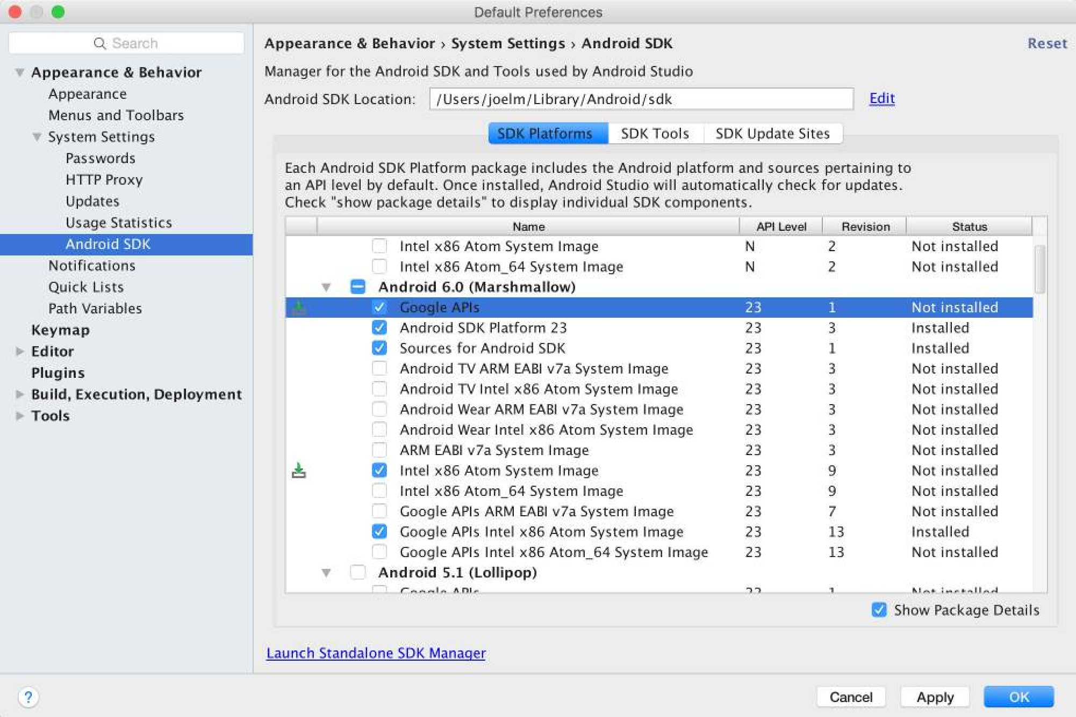

In the SDK Tools window, choose Show Package Details and under Android SDK Build Tools, make sure that Android SDK Build-Tools 23.0.1 is selected.

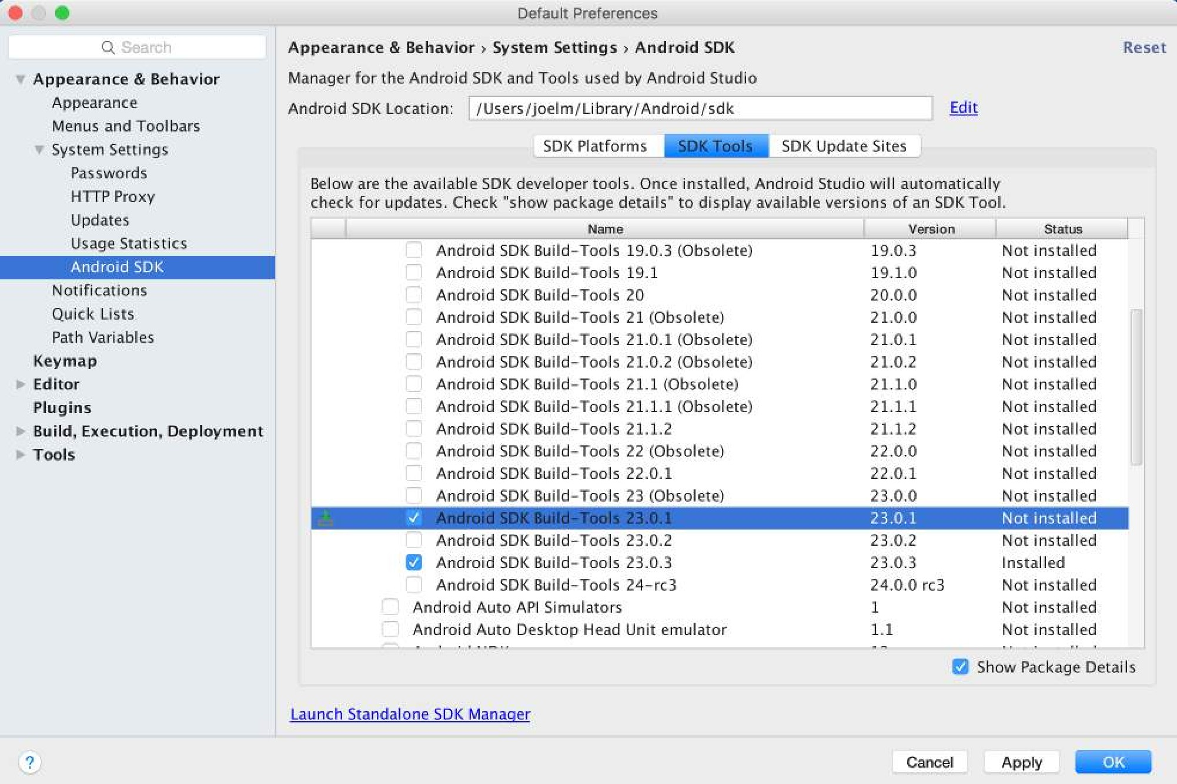

Environment Variable ANDROID_HOME

Ensure the ANDROID_HOME environment variable points to your existing Android SDK. To do that, add this to your ~/.bashrc, ~/.bash_profile (or whatever your shell uses) and re-open your terminal:

If you installed the SDK without Android Studio, then it may be something like: /usr/local/opt/android-sdk

export

ANDROID_HOME

=

~

/

Library

/

Android

/

sdk

**Dependencies for Mac**

You will need Xcode for iOS and Android Studio for android, node.js, the React Native command line tools, and Watchman.

We recommend installing node and watchman via Homebrew.

brew install node

brew install watchman

Watchma

[n](https://facebook.github.io/watchman)

is a tool by Facebook for watching changes in the filesystem. It is highly recommended you

install it for better performance. It is optional.

Node comes with npm, which lets you install the React Native command line interface.

npm

**install**

-

g

react-native-cli

If you get a permission error, try with sudo:

**sudo**

npm

**install**

-

g

react-native-cli.

For iOS the easiest way to install Xcode is via the Mac App Store. And for android download and install Android Studio.

If you plan to make changes in Java code, we recommend Gradle Daemon which speeds up the build.

**Testing your React Native Installation**

Use the React Native command line tools to generate a new React Native project called "AwesomeProject", then run react-native run-ios inside the newly created folder.

react-native init AwesomeProject

**cd**

AwesomeProject

react-native run-ios

You should see your new app running in the iOS Simulator shortly. react-native run-ios is just one way to run your app - you can also run it directly from within Xcode or Nuclide.

**Modifying your app**

Now that you have successfully run the app, let's modify it.

Open index.ios.js or index.android.js in your text editor of choice and edit some lines.

Hit Command⌘ + R in your iOS Simulator to reload the app and see your change! That's it!

Congratulations! You've successfully run and modified your first React Native app.

source: [Getting Started - React-Native](http://facebook.github.io/react-native/docs/getting-started.html)

## Section 1.2: Setup for Linux (Ubuntu)

1. **Setup Node.JS**

**Start the terminal and run the following commands to install nodeJS:** curl -sL https:**//**deb.nodesource.com**/**setup_5.x **|** **sudo** -E **bash** -

**sudo**

**apt-get install**

nodejs

**If node command is unavailable**

**sudo**

**ln**

-

s

**/**

usr

**/**

bin

**/**

nodejs

**/**

usr

**/**

bin

**/**

node

**Alternatives NodeJS instalations:**

curl

-

sL

https:

**//**

deb.nodesource.com

**/**

setup_6.x

**|**

**sudo**

-

E

**bash**

-

**sudo**

**apt-get install**

-

y

nodejs

or

curl

-

sL

https:

**//**

deb.nodesource.com

**/**

setup_7.x

**|**

**sudo**

-

E

**bash**

-

**sudo**

**apt-get install**

-

y

nodejs

**check if you have the current version**

node

-

v

**Run the npm to install the react-native sudo** npm **install** -g react-native-cli

1. **Setup Java**

**sudo**

**apt-get install**

lib32stdc++

6

lib32z1 openjdk-

7

-

jdk

1. **Setup Android Studio:**

**Android SDK or Android Studio**

http

:

*//developer.android.com/sdk/index.html*

**Android SDK e ENV**

export ANDROID_HOME=/YOUR/LOCAL/ANDROID/SDK

export PATH=$PATH:$ANDROID_HOME/tools:$ANDROID_HOME/platform-tools

1. **Setup emulator:**

On the terminal run the command

android

Select "SDK Platforms" from within the SDK Manager and you should see a blue checkmark next to "Android 7.0 (Nougat)". In case it is not, click on the checkbox and then "Apply".

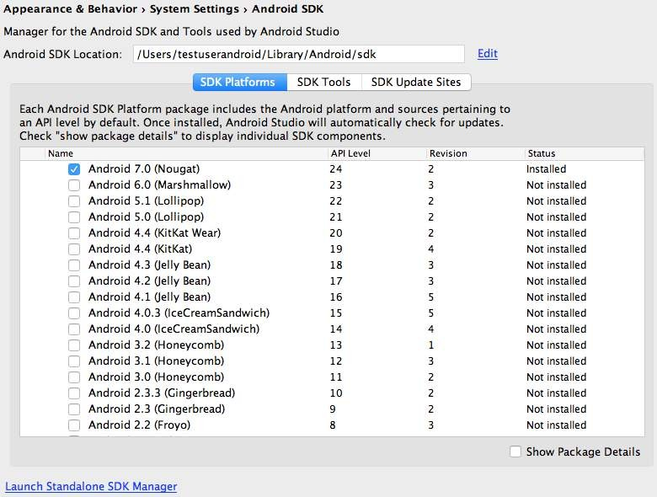

1. **Start a project**

**Example app init**

react-native init ReactNativeDemo

**&&**

**cd**

ReactNativeDemo

|  |  |  |  |  |
| --- | --- | --- | --- | --- |
| **android** | **/** | **app** | **/** | **build.gradle** |

**Obs: Always check if the version on is the same as the Build Tools downloaded on your android SDK**

android

{

compileSdkVersion XX

buildToolsVersion

"XX.X.X"

...

1. **Run the project**

**Open Android AVD to set up a virtual android. Execute the command line:**

android avd

Follow the instructions to create a virtual device and start it

Open another terminal and run the command lines:

react

-

native

run

-

android

react

-

native

start

## Section 1.3: Setup for Windows

Note: You cannot develop react-native apps for iOS on Windows, only react-native android apps.

The official setup docs for react-native on windows can be [found here](https://facebook.github.io/react-native/docs/getting-started.html#dependencies-for-windows-android). If you need more details there is a [granular guide here](http://bitvbit.blogspot.com/2016/07/react-native-android-apps-on-windows.html).

**Tools/Environment**

Windows 10

command line tool (eg Powershell or windows command line)

[Chocolatey](https://chocolatey.org/) ([steps to setup via PowerShell](http://bitvbit.blogspot.com/2016/07/react-native-android-apps-on-windows.html#setup-choco))

The JDK (version 8)

Android Studio

An Intel machine with Virtualization technology enabled for HAXM (optional, only needed if you want to use an emulator)

1. **Setup your machine for react native development**

Start the command line as an administrator run the following commands:

choco install nodejs.

install

choco install python2

Restart command line as an administrator so you can run npm

npm

**install**

-

g

react-native-cli

|  |  |  |  |  |  |  |
| --- | --- | --- | --- | --- | --- | --- |
| \Program Files | ( | x86 | ) | \Nodist\v | - | x64\6.2.2 |

After running the last command copy the directory that react-native was installed in. You will need this for Step 4. I tried this on two computers in one case it was: C:. In the other it was:

|  |
| --- |
| \Users\admin\AppData\Roaming\npm |

C:

1. **Set your Environment Variables**

[A Step by Step guide with images can be found here for this section.](http://bitvbit.blogspot.com/2016/07/react-native-android-apps-on-windows.html)

Open the Environment Variables window by navigating to:

[Right click] "Start" menu -> System -> Advanced System Settings -> Environment Variables

In the bottom section find the "Path" System Variable and add the location that react-native was installed to in step 1.

If you haven't added an ANDROID_HOME environment variable you will have to do that here too. While still in the "Environment Variables" window, add a new System Variable with the name "ANDROID_HOME" and value as the path to your android sdk.

Then restart the command line as an admin so you can run react-native commands in it.

1. **Create your project** In command line, navigate to the folder you want to place your project and run the following command:

react

-

native

init ProjectName

1. **Run your project** Start an emulator from android studio Navigate to the root directory of your project in command line and run it:

**cd**

ProjectName

react-native run-android

You may run into dependency issues. For example, there may be an error that you do not have the correct build tools version. To fix this you will have to open [the sdk manager in Android Studio](https://developer.android.com/studio/intro/update.html#sdk-manager) and download the build tools from there.

**Congrats!**

|  |  |  |
| --- | --- | --- |
| ctrl | + | m |

To refresh the ui you can press the r key twice while in the emulator and running the app. To see developer options you can press .

# Chapter 2: Hello World

## Section 2.1: Editing index.ios.js or index.android.js

|  |  |  |  |  |
| --- | --- | --- | --- | --- |
| index.ios.js | or | index.android.js | and delete everything between the | **<View>** **</View>** |

Open . After that, write

|  |
| --- |
| **<Text>** Hello World! **</Text>** |

and run the emulator.

|  |
| --- |
| Hello World! |

You should see written on the screen!

Congrats! You've successfully written your first Hello World!

## Section 2.2: Hello world!

import

React

,

{

Component

}

from

'react'

;

import

{

AppRegistry

,

Text

}

from

'react-native'

;

class

HelloWorldApp

extends

Component

{

render

(

)

{

**return**

(

<

Text

>

Hello world

!<

/

Text

>

)

;

}

}

AppRegistry.

registerComponent

(

'HelloWorldApp'

,

(

)

=>

HelloWorldApp

)

;

# Chapter 3: Props

Props, or properties, are data that is passed to child components in a React application. React components render UI elements based on their props and their internal state. The props that a component takes (and uses) defines how it can be controlled from the outside.

## Section 3.1: PropTypes

|  |  |  |
| --- | --- | --- |
| prop | - | types |

The package allows you to add runtime type checking to your component that ensures the types of the props passed to the component are correct. For instance, if you don't pass a name or isYummy prop to the component below it will throw an error in development mode. In production mode the prop type checks are not done. Defining propTypes can make your component more readable and maintainable.

import

React

,

{

Component

}

from

'react'

;

import

PropTypes from

'prop-types'

;

import

{

AppRegistry

,

Text

,

View

}

from

'react-native'

;

import

styles from

'./styles.js'

;

class

Recipe

extends

Component

{

**static**

propTypes

=

{

name

:

PropTypes.

string

.

isRequired

,

isYummy

:

PropTypes.

bool

.

isRequired

}

render

(

)

{

**return**

(

<

View style

=

{

styles.

container

}

>

<

Text

>

{

**this**

.

props

.

name

}

<

/

Text

>

{

**this**

.

props

.

isYummy

?

<

Text

>

THIS RECIPE IS YUMMY

<

/

Text

>

:

**null**

}

<

/

View

>

)

}

}

AppRegistry.

registerComponent

(

'Recipe'

,

(

)

=>

Recipe

)

;

*// Using the component*

<

Recipe name

=

"Pancakes"

isYummy

=

{

**true**

}

/>

**Multiple PropTypes**

You can also have multiple propTypes for one props. For example, the name props I'm taking can also be an object, I can write it as.

**static**

propTypes

=

{

name

:

PropTypes.

oneOfType

(

[

PropTypes.

string

,

PropTypes.

object

]

)

}

**Children Props**

There is also a special props called children, which is **not** passed in like

**<**

**Recipe**

children

=

{

something

}

**/>**

Instead, you should do this

**<**

**Recipe**

**>**

**<**

**Text**

**>**

Hello React Native

**<**

**/Text**

**>**

**<**

**/Recipe**

**>**

then you can do this in Recipe's render:

**return**

(

<

View style

=

{

styles.

container

}

>

{

**this**

.

props

.

children

}

{

**this**

.

props

.

isYummy

?

<

Text

>

THIS RECIPE IS YUMMY

<

/

Text

>

:

**null**

}

<

/

View

>

)

|  |
| --- |
| **<Text** |

You will have a **>** component in your Recipe saying Hello React Native, pretty cool hum?

And the propType of children is

children

:

PropTypes.

node

## Section 3.2: What are props?

Props are used to transfer data from parent to child component. Props are read only. Child component can only get the props passed from parent using **this.props.keyName**. Using props one can make his component reusable.

## Section 3.3: Use of props

|  |  |  |  |  |  |  |
| --- | --- | --- | --- | --- | --- | --- |
| index.android | . | js | or to | index.ios | . | js |

Once setup is completed. Copy the code below to file to use the props.

import

React

,

{

Component

}

from

'react'

;

import

{

AppRegistry

,

Text

,

View

}

from

'react-native'

;

class

Greeting

extends

Component

{

render

(

)

{

**return**

(

<

Text

>

Hello

{

**this**

.

props

.

name

}

!<

/

Text

>

)

;

}

}

class

LotsOfGreetings

extends

Component

{

render

(

)

{

**return**

(

<

View style

=

{

{

alignItems

:

'center'

}

}

>

<

Greeting name

=

'Rexxar'

/>

<

Greeting name

=

'Jaina'

/>

<

Greeting name

=

'Valeera'

/>

<

/

View

>

)

;

}

}

AppRegistry.

registerComponent

(

'LotsOfGreetings'

,

(

)

=>

LotsOfGreetings

)

;

Using props one can make his component generic. For example, you have a Button component. You can pass different props to that component, so that one can place that button anywhere in his view.

source: [Props-React Native](http://facebook.github.io/react-native/docs/props.html)

## Section 3.4: Default Props

defaultProps allows you to set default prop values for your component. In the below example if you do not pass the name props, it will display John otherwise it will display the passed value

class

Example

extends

Component

{

render

(

)

{

**return**

(

<

View

>

<

Text

>

{

**this**

.

props

.

name

}

<

/

Text

>

<

/

View

>

)

}

}

Example.

defaultProps

=

{

name

:

'John'

}

# Chapter 4: Multiple props rendering

## Section 4.1: render multiple variables

For rendering multiple props or variables we can use **``**.

render

(

)

{

**let**

firstName

=

'test'

;

**let**

lastName

=

'name'

;

**return**

(

<

View style

=

{

styles.

container

}

>

<

Text

>

{

`$

{

firstName

}

$

{

lastName

}

`

}

<

/

Text

>

<

/

View

>

)

;

}

Output: test name

# Chapter 5: Modal

|  |  |
| --- | --- |
| **Prop** | **details** |
| animationType | it's an enum of ('**none**', '**slide**', '**fade**') and it controls modal animation. |
| visible | its a bool that controls modal visiblity. |
| onShow | it allows passing a function that will be called once the modal has been shown. |
| transparent | bool to set transparency. |

onRequestClose (**android**) it always defining a method that will be called when user tabs back button onOrientationChange (**IOS**) it always defining a method that will be called when orientation changes

supportedOrientations (**IOS**) enum('portrait', 'portrait-upside-down', 'landscape', 'landscape-left', 'landscape-right') Modal component is a simple way to present content above an enclosing view.

## Section 5.1: Modal Basic Example

import

React

,

{

Component

}

from

'react'

;

import

{

Modal

,

Text

,

View

,

Button

,

StyleSheet

,

}

from

'react-native'

;

**const**

styles

=

StyleSheet.

create

(

{

mainContainer

:

{

marginTop

:

22

,

}

,

modalContainer

:

{

marginTop

:

22

,

}

,

}

)

;

class

Example

extends

Component

{

constructor

(

)

{

super

(

)

;

**this**

.

state

=

{

visibility

:

**false**

,

}

;

}

setModalVisibility

(

visible

)

{

**this**

.

setState

(

{

visibility

:

visible

,

}

)

;

}

render

(

)

{

**return**

(

<

View style

=

{

styles.

mainContainer

}

>

<

Modal

animationType

=

{

'slide'

}

transparent

=

{

**false**

}

visible

=

{

**this**

.

state

.

visibility

}

>

<

View style

=

{

styles.

modalContainer

}

>

<

View

>

<

Text

>

I

'm a simple Modal</Text>

<Button

color="#000"

onPress={() => this.setModalVisibility(!this.state.visibility)}

title="Hide Modal"

/>

</View>

</View>

</Modal>

<Button

color="#000"

onPress={() => this.setModalVisibility(true)}

title="Show Modal"

/>

</View>

);

}

}

export default Example;

## Section 5.2: Transparent Modal Example

See this example [here](https://snack.expo.io/Skq5Inanl).

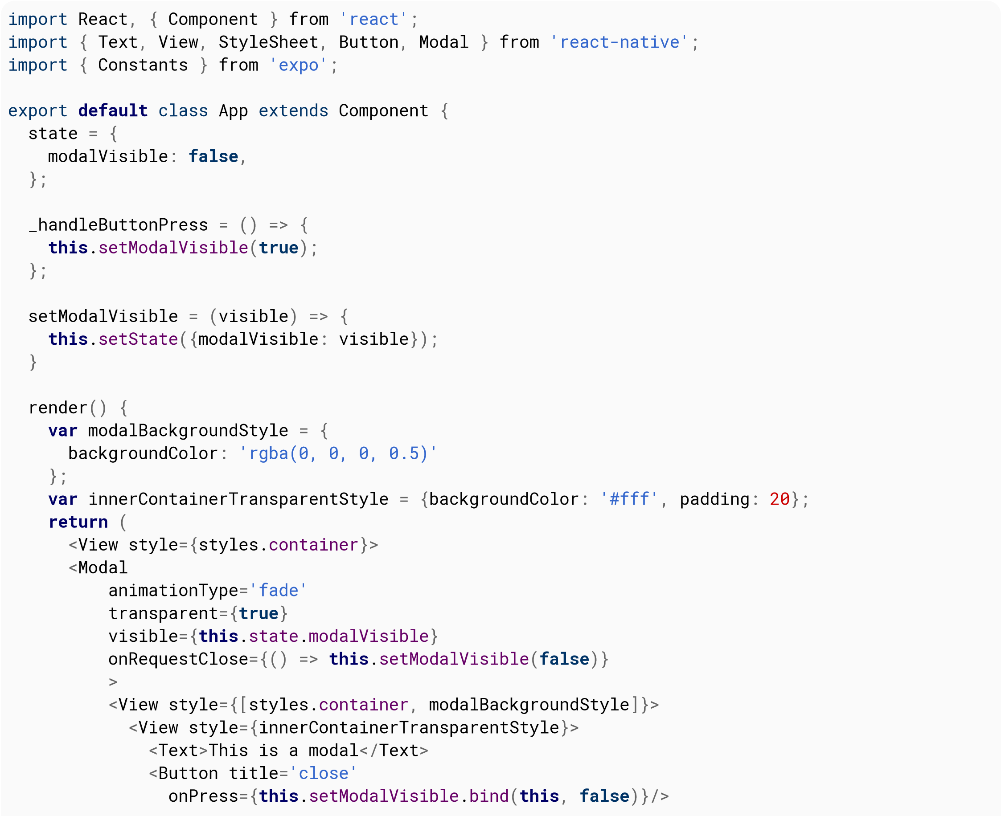

<

/

View

>

<

/

View

>

<

/

Modal

>

<

Button

title

=

"Press me"

onPress

=

{

**this**

._handleButtonPress

}

/>

<

/

View

>

)

;

}

}

**const**

styles

=

StyleSheet.

create

(

{

container

:

{

flex

:

1

,

alignItems

:

'center'

,

justifyContent

:

'center'

,

paddingTop

:

Constants.

statusBarHeight

,

backgroundColor

:

'#ecf0f1'

,

}

}

)

;

# Chapter 6: State

## Section 6.1: setState

To change view in your application you can use setState - this will re-render your component and any of its child components. setState performs a shallow merge between the new and previous state, and triggers a re-render of the component.

setState takes either a key-value object or a function that returns a key-value object **Key-Value Object**

**this**

.

setState

(

{

myKey

:

'myValue'

}

)

;

**Function**

Using a function is useful for updating a value based off the existing state or props.

**this**

.

setState

(

(

previousState

,

currentProps

)

=>

{

**return**

{

myInteger

:

previousState.

myInteger

+

1

}

}

)

You can also pass an optional callback to setState that will be fired when the component has re-rendered with the new state.

**this**

.

setState

(

{

myKey

:

'myValue'

}

,

(

)

=>

{

*// Component has re-rendered... do something amazing!*

)

)

;

**Full Example**

import

React

,

{

Component

}

from

'react'

;

import

{

AppRegistry

,

StyleSheet

,

Text

,

View

,

TouchableOpacity

}

from

'react-native'

;

export

**default**

class

MyParentComponent

extends

Component

{

constructor

(

props

)

{

super

(

props

)

;

**this**

.

state

=

{

myInteger

:

0

}

}

getRandomInteger

(

)

{

**const**

randomInt

=

Math

.

floor

(

Math

.

random

(

)

*

100

)

;

**this**

.

setState

(

{

myInteger

:

randomInt

}

)

;

}

incrementInteger

(

)

{

**this**

.

setState

(

(

previousState

,

currentProps

)

=>

{

**return**

{

myInteger

:

previousState.

myInteger

+

1

}

|  |
| --- |
| });  } render() {  **return** <View style={styles.container}>  <Text>Parent Component Integer: {**this**.state.myInteger}</Text>  <MyChildComponent myInteger={**this**.state.myInteger} />  <Button label="Get Random Integer" onPress={**this**.getRandomInteger.bind(**this**)} /> <Button label="Increment Integer" onPress={**this**.incrementInteger.bind(**this**)} />  </View>  } }  export **default** class MyChildComponent extends Component { constructor(props) { super(props); }  render() {  *// this will get updated when "MyParentComponent" state changes*  **return** <View> <Text>Child Component Integer: {**this**.props.myInteger}</Text>  </View>    } }  export **default** class Button extends Component { constructor(props) { super(props); } render() {  **return** <TouchableOpacity onPress={**this**.props.onPress}> <View style={styles.button}>  <Text style={styles.buttonText}>{**this**.props.label}</Text>  </View>  </TouchableOpacity>    } }  **const** styles = StyleSheet.create({ container: { flex: 1, justifyContent: 'center', alignItems: 'center', backgroundColor: '#F5FCFF', }, button: { backgroundColor: '#444', padding: 10, marginTop: 10 }, buttonText: { color: '#fff' |

}

}

)

;

AppRegistry.

registerComponent

(

'MyApp'

,

(

)

=>

MyParentComponent

)

;

## Section 6.2: Initialize State

You should initialize state inside the constructor function of your component like this:

export

**default**

class

MyComponent

extends

Component

{

constructor

(

props

)

{

super

(

props

)

;

**this**

.

state

=

{

myInteger

:

0

}

}

render

(

)

{

**return**

(

<

View

>

<

Text

>

Integer

:

{

**this**

.

state

.

myInteger

}

<

/

Text

>

<

/

View

>

)

}

}

Using setState one can update the view.

# Chapter 7: Routing

Routing or navigation allows applications to between different screens. Its vital to a mobile app as it provides context to user about where they are, decouple user actions between screens and move between them, provide a state machine like model of the whole app.

## Section 7.1: Navigator component

Navigator works for both IOS and android.

import

React

,

{

Component

}

from

'react'

;

import

{

Text

,

Navigator

,

TouchableHighlight

}

from

'react-native'

;

export

**default**

class

NavAllDay

extends

Component

{

render

(

)

{

**return**

(

<

Navigator

initialRoute

=

{

{

title

:

'Awesome Scene'

,

index

:

0

}

}

renderScene

=

{

(

route

,

navigator

)

=>

<

Text

>

Hello

{

route.

title

}

!<

/

Text

>

}

style

=

{

{

padding

:

100

}

}

/>

)

;

}

}

Routes to Navigator are provided as objects. You also provide a renderScene function that renders the scene for each route object. initialRoute is used to specify the first route.

# Chapter 8: Styling

Styles are defined within a JSON object with similar styling attribute names like in CSS. Such an object can either be

|  |  |  |
| --- | --- | --- |
| StyleSheet.create | ( | StyleObject |

put inline in the style prop of a component or it can be passed to the function ) and be stored in a variable for shorter inline access by using a selector name for it similar to a class in CSS.

## Section 8.1: Conditional Styling

**<View** style={[(this.props.isTrue) ? styles.bgcolorBlack : styles.bgColorWhite]}**>**

If the value of isTrue is **true** then it will have black background color otherwise white.

## Section 8.2: Styling using inline styles

Each React Native component can take a style prop. You can pass it a JavaScript object with CSS-style style properties:

**<**

**Text**

style

=

{

{

color:

'red'

}

}

**>**

Red text

**<**

**/Text**

**>**

This can be inefficient as it has to recreate the object each time the component is rendered. Using a stylesheet is preferred.

## Section 8.3: Styling using a stylesheet

import

React

,

{

Component

}

from

'react'

;

import

{

View

,

Text

,

StyleSheet

}

from

'react-native'

;

**const**

styles

=

StyleSheet.

create

(

{

red

:

{

color

:

'red'

}

,

big

:

{

fontSize

:

30

}

}

)

;

class

Example

extends

Component

{

render

(

)

{

**return**

(

<

View

>

<

Text style

=

{

styles.

red

}

>

Red

<

/

Text

>

<

Text style

=

{

styles.

big

}

>

Big

<

/

Text

>

<

/

View

>

)

;

}

}

|  |
| --- |
| StyleSheet.create |

() returns an object where the values are numbers. React Native knows to convert these

numeric IDs into the correct style object.

## Section 8.4: Adding multiple styles

You can pass an array to the style prop to apply multiple styles. When there is a conflict, the last one in the list takes precedence.

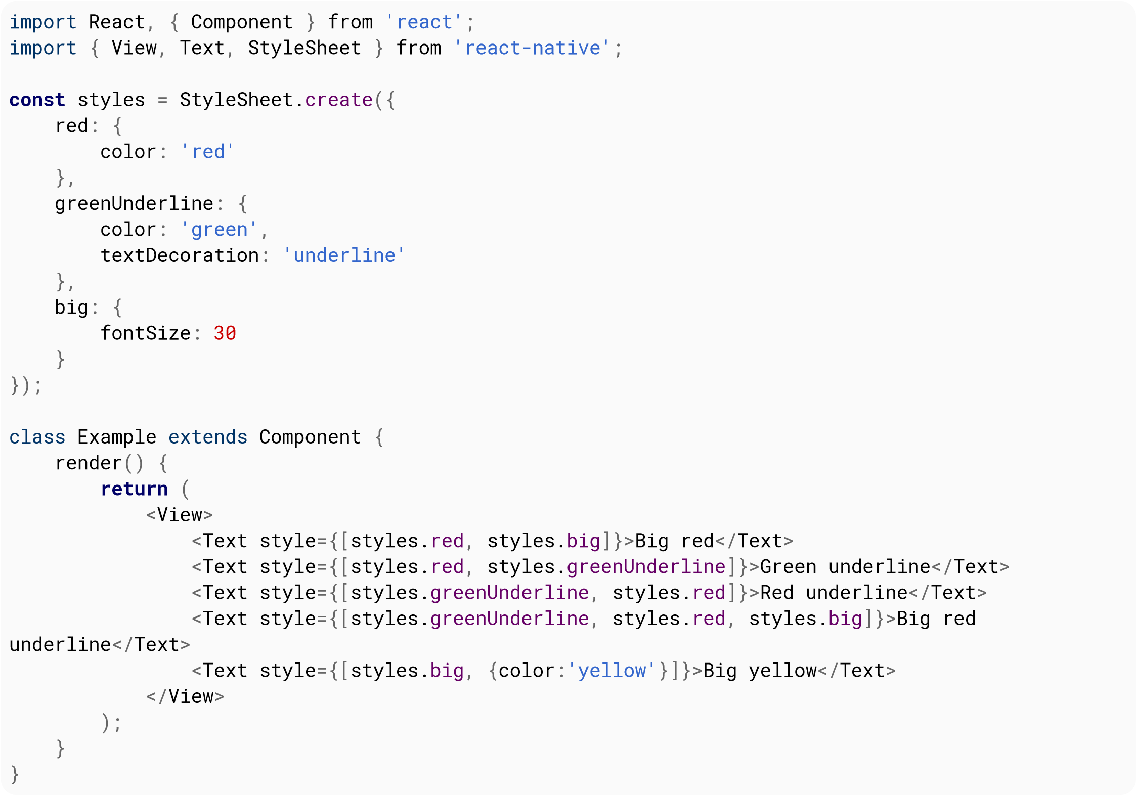

# Chapter 9: Layout

## Section 9.1: Flexbox

|  |
| --- |
| flexDirection: 'row' |

Flexbox is a layout mode providing for the arrangement of elements on a page such that the elements behave predictably when the page layout must accommodate different screen sizes and different display devices. By default flexbox arranges children in a column. But you can change it to row using .

**flexDirection**

**const**

Direction

=

(

props

)

=>

{

**return**

(

<

View style

=

{

styles.

container

}

>

<

Box

/>

<

Box

/>

<

Box

/>

<

View style

=

{

{

flexDirection

:

'row'

}

}

>

<

Box

/>

<

Box

/>

<

Box

/>

<

/

View

>

<

/

View

>

)

}

**const**

styles

=

StyleSheet.

create

(

{

container

:

{

flex

:

1

,

backgroundColor

:

'#AED581'

,

}

}

)

;

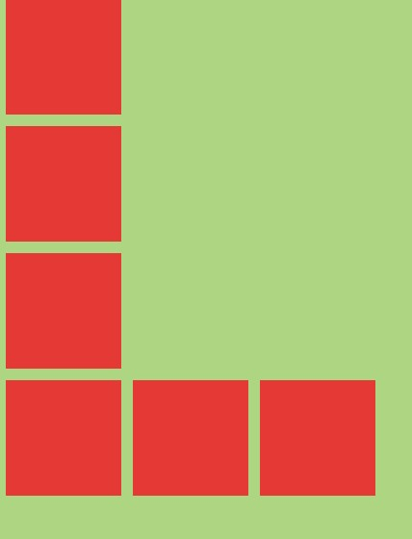

**Alignment axis**

**const**

AlignmentAxis

=

(

props

)

=>

{

**return**

(

<

View style

=

{

styles.

container

}

>

<

Box

/>

<

View style

=

{

{

flex

:

1

,

alignItems

:

'flex-end'

,

justifyContent

:

'flex-end'

}

}

>

<

Box

/>

<

Box

/>

<

/

View

>

<

Box

/>

<

/

View

>

)

}

**const**

styles

=

StyleSheet.

create

(

{

container

:

{

flex

:

1

,

backgroundColor

:

`#69B8CC`

,

}

,

text

:

{

color

:

'white'

,

textAlign

:

'center'

}

}

)

;

[GoalKicker.com – React Native Notes for Professionals](https://goalkicker.com/) 28

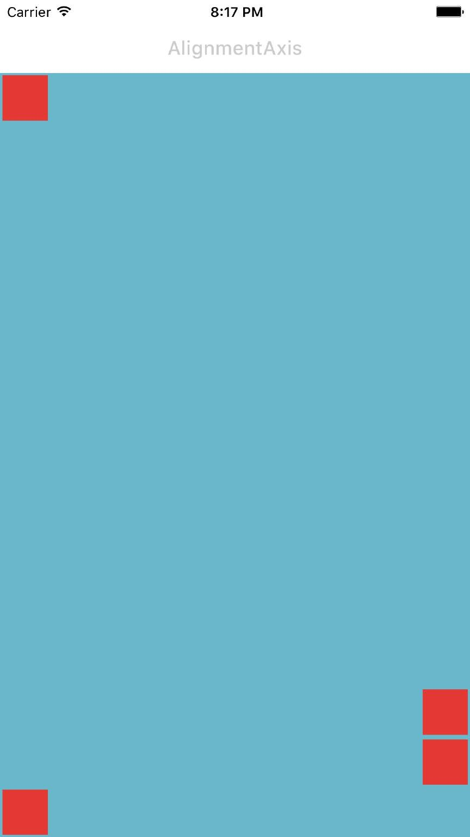

**Alignment**

**const**

Alignment

=

(

props

)

=>

{

**return**

(

<

View style

=

{

styles.

container

}

>

<

Box

/>

<

View style

=

{

{

alignItems

:

'center'

}

}

>

<

Box

/>

<

View style

=

{

{

flexDirection

:

'row'

}

}

>

<

Box

/>

<

Box

/>

<

Box

/>

<

/

View

>

<

Box

/>

<

/

View

>

<

Box

/>

<

/

View

>

)

}

**const**

styles

=

StyleSheet.

create

(

{

container

:

{

flex

:

1

,

backgroundColor

:

`#69B8CC`

,

}

,

text

:

{

color

:

'white'

,

textAlign

:

'center'

}

}

)

;



**Flex size**

**const**

FlexSize

=

(

props

)

=>

{

**return**

(

[GoalKicker.com – React Native Notes for Professionals](https://goalkicker.com/) 30

<

View style

=

{

styles.

container

}

>

<

View style

=

{

{

flex

:

0.1

}

}

>

<

Box style

=

{

{

flex

:

0.7

}

}

/>

<

Box style

=

{

{

backgroundColor

:

'yellow'

}

}

/>

<

Box

/>

<

Box style

=

{

{

flex

:

0.3

,

backgroundColor

:

'yellow'

}

}

/>

<

/

View

>

<

View style

=

{

{

flex

:

0.1

}

}

>

<

Box style

=

{

{

flex

:

1

}

}

/>

<

Box style

=

{

{

backgroundColor

:

'yellow'

}

}

/>

<

Box

/>

<

Box style

=

{

{

flex

:

1

,

backgroundColor

:

'yellow'

}

}

/>

<

/

View

>

<

/

View

>

)

}

**const**

styles

=

StyleSheet.

create

(

{

container

:

{

flex

:

1

,

flexDirection

:

'row'

,

backgroundColor

:

colors

[

1

]

,

}

,

}

)

;

[GoalKicker.com – React Native Notes for Professionals](https://goalkicker.com/) 32



More about Facebook's flexbox implementation [here](https://github.com/facebook/yoga).

# Chapter 10: Components

## Section 10.1: Basic Component

import

React

,

{

Component

}

from

'react'

import

{

View

,

Text

,

AppRegistry

}

from

'react-native'

class

Example

extends

Component

{

render

(

)

{

**return**

(

<

View

>

<

Text

>

I

'm a basic Component </Text>

</View>

)

}

}

AppRegistry.registerComponent('

Example

', () => Example)

## Section 10.2: Stateful Component

These components will have changing States.

import

React

,

{

Component

}

from

'react'

import

{

View

,

Text

,

AppRegistry

}

from

'react-native'

class

Example

extends

Component

{

constructor

(

props

)

{

super

(

props

)

**this**

.

state

=

{

name

:

"Sriraman"

}

}

render

(

)

{

**return**

(

<

View

>

<

Text

>

Hi

,

{

**this**

.

state

.

name

}

<

/

Text

>

<

/

View

>

)

}

}

AppRegistry.

registerComponent

(

'Example'

,

(

)

=>

Example

)

## Section 10.3: Stateless Component

As the name implies, Stateless Components do not have any local state. They are also known as **Dumb**

**Components**. Without any local state, these components do not need lifecycle methods or much of the boilerplate that comes with a stateful component.

|  |
| --- |
| **const** name = ({props}) => ( ... ) |

Class syntax is not required, you can simply do . Generally stateless components are more concise as a result.

Beneath is an example of two stateless components App and Title, with a demonstration of passing props between components:

import

React from

'react'

import

{

View

,

Text

,

AppRegistry

}

from

'react-native'

**const**

Title

=

(

{

Message

}

)

=>

(

<

Text

>

{

Message

}

<

/

Text

>

)

**const**

App

=

(

)

=>

(

<

View

>

<

Title title

=

'Example Stateless Component'

/>

<

/

View

>

)

AppRegistry.

registerComponent

(

'App'

,

(

)

=>

App

)

This is the recommended pattern for components, when possible. As in the future optimisations can be made for these components, reducing memory allocations and unnecessary checks.

# Chapter 11: ListView

## Section 11.1: Simple Example

ListView - A core component designed for efficient display of vertically scrolling lists of changing data. The minimal API is to create a ListView.DataSource, populate it with a simple array of data blobs, and instantiate a ListView component with that data source and a renderRow callback which takes a blob from the data array and returns a renderable component.

Minimal example:

getInitialState

:

**function**

(

)

{

**var**

ds

=

**new**

ListView.

DataSource

(

{

rowHasChanged

:

(

r1

,

r2

)

=>

r1

!==

r2

}

)

;

**return**

{

dataSource

:

ds.

cloneWithRows

(

[

'row 1'

,

'row 2'

]

)

,

}

;

}

,

render

:

**function**

(

)

{

**return**

(

<

ListView

dataSource

=

{

**this**

.

state

.

dataSource

}

renderRow

=

{

(

rowData

)

=>

<

Text

>

{

rowData

}

<

/

Text

>

}

/>

)

;

}

,

ListView also supports more advanced features, including sections with sticky section headers, header and footer support, callbacks on reaching the end of the available data (onEndReached) and on the set of rows that are visible in the device viewport change (onChangeVisibleRows), and several performance optimizations.

There are a few performance operations designed to make ListView scroll smoothly while dynamically loading potentially very large (or conceptually infinite) data sets:

Only re-render changed rows - the rowHasChanged function provided to the data source tells the ListView if it needs to re-render a row because the source data has changed - see ListViewDataSource for more details. Rate-limited row rendering - By default, only one row is rendered per event-loop (customizable with the pageSize prop). This breaks up the work into smaller chunks to reduce the chance of dropping frames while rendering rows.

# Chapter 12: RefreshControl with ListView

## Section 12.1: Refresh Control with ListView Full Example

**RefreshControl** is used inside a ScrollView or ListView to add pull to refresh functionality. at this example we will use it with ListView

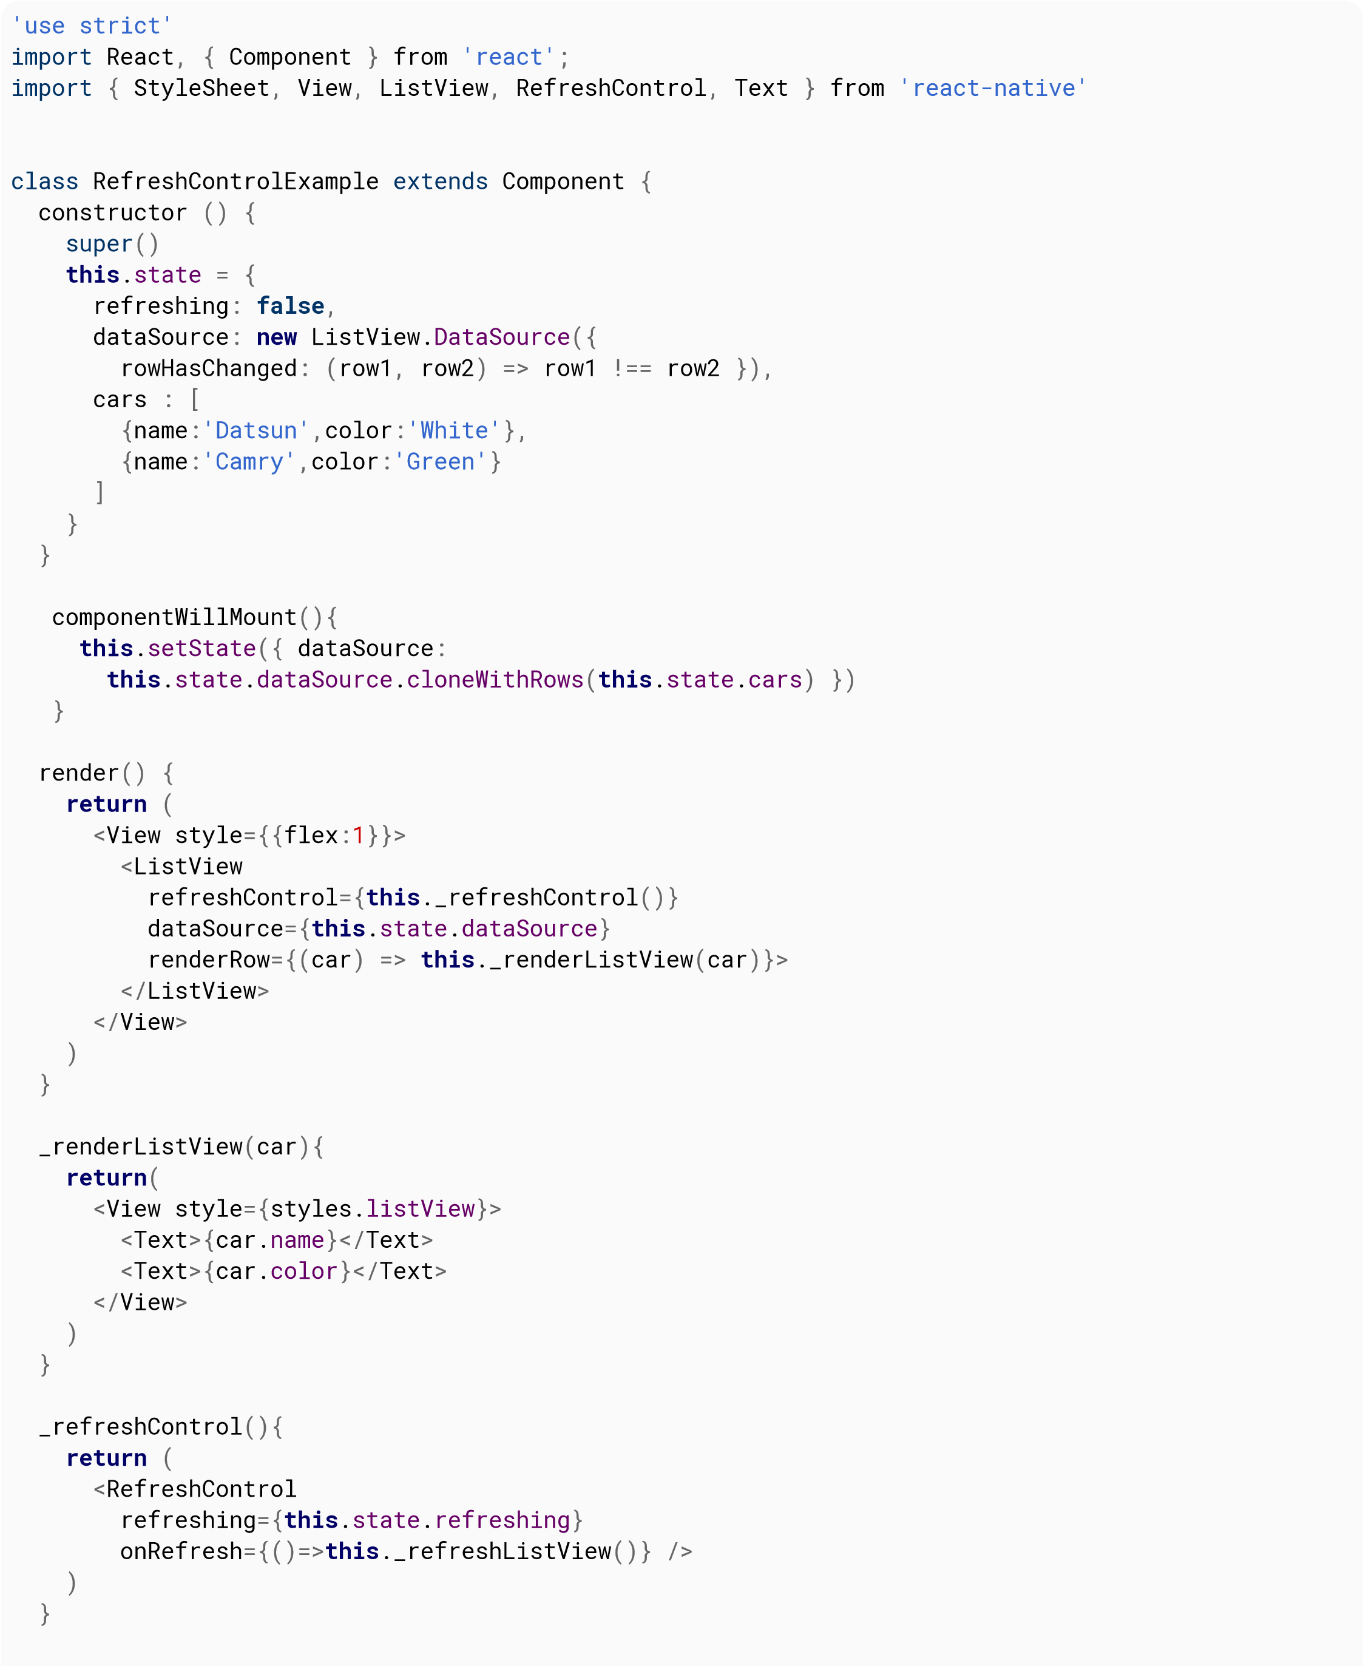

_refreshListView

(

)

{

*//Start Rendering Spinner*

**this**

.

setState

(

{

refreshing

:

**true**

}

)

**this**

.

state

.

cars

.

push

(

{

name

:

'Fusion'

,

color

:

'Black'

}

,

{

name

:

'Yaris'

,

color

:

'Blue'

}

)

*//Updating the dataSource with new data*

**this**

.

setState

(

{

dataSource

:

**this**

.

state

.

dataSource

.

cloneWithRows

(

**this**

.

state

.

cars

)

}

)

**this**

.

setState

(

{

refreshing

:

**false**

}

)

*//Stop Rendering Spinner*

}

}

**const**

styles

=

StyleSheet.

create

(

{

listView

:

{

flex

:

1

,

backgroundColor

:

'#fff'

,

marginTop

:

10

,

marginRight

:

10

,

marginLeft

:

10

,

padding

:

10

,

borderWidth

:

.5

,

borderColor

:

'#dddddd'

,

height

:

70

}

}

)

module.

exports

=

RefreshControlExample

## Section 12.2: Refresh Control

_refreshControl

(

)

{

**return**

(

<

RefreshControl

refreshing

=

{

**this**

.

state

.

refreshing

}

onRefresh

=

{

(

)

=>

**this**

._refreshListView

(

)

}

/>

)

}

**refreshing:** is the state of the spinner (true, false).

**onRefresh:** this function will invoke when refresh the ListView/ScrollView.

## Section 12.3: onRefresh function Example

_refreshListView

(

)

{

*//Start Rendering Spinner*

**this**

.

setState

(

{

refreshing

:

**true**

}

)

**this**

.

state

.

cars

.

push

(

{

name

:

'Fusion'

,

color

:

'Black'

}

,

{

name

:

'Yaris'

,

color

:

'Blue'

}

)

*//Updating the dataSource with new data*

**this**

.

setState

(

{

dataSource

:

**this**

.

state

.

dataSource

.

cloneWithRows

(

**this**

.

state

.

cars

)

}

)

**this**

.

setState

(

{

refreshing

:

**false**

}

)

*//Stop Rendering Spinner*

}

here we are updating the array and after that we will update the dataSource. we can use [fetch](https://github.com/github/fetch) to request something from server and use async/await.

# Chapter 13: WebView

Webview can be used to load external webpages or html content. This component is there by default.

## Section 13.1: Simple component using webview

import

React

,

{

Component

}

from

'react'

;

import

{

WebView

}

from

'react-native'

;

class

MyWeb

extends

Component

{

render

(

)

{

**return**

(

<

WebView

source

=

{

{

uri

:

'https://github.com/facebook/react-native'

}

}

style

=

{

{

marginTop

:

20

}

}

/>

)

;

}

}

# Chapter 14: Command Line Instructions

## Section 14.1: Check version installed

$ react

-

native

-

v

Example Output

react-native-cli: 0.2.0 react-native: n/a - not inside a React Native project directory *//Output from different folder* react-native: react-native: 0.30.0 *// Output from the react native project directory*

## Section 14.2: Initialize and getting started with React Native project

**To initialize**

react

-

native

init MyAwesomeProject

**To initialize with a specific version of React Native**

react

-

native

init

--

version

=

"0.36.0"

MyAwesomeProject

**To Run for Android**

**cd**

MyAwesomeProject

react-native run-android

**To Run for iOS**

**cd**

MyAwesomeProject

react-native run-ios

## Section 14.3: Upgrade existing project to latest RN version

|  |
| --- |
| package.json |

In the app folder find and modify the following line to include the latest version, save the file and close.

"react-native"

:

"0.32.0"

In terminal:

$

npm

**install**

Followed by

$ react

-

native

upgrade

## Section 14.4: Add android project for your app

If you either have apps generated with pre-android support or just did that on purpose, you can always add android project to your app.

$ react

-

native

android

|  |
| --- |
| index.android.js |

This will generate android folder and inside your app.

## Section 14.5: Logging

**Android**

$ react

-

native

log

-

android

**iOS**

$ react

-

native

log

-

ios

## Section 14.6: Start React Native Packager

$ react

-

native

start

On latest version of React Native, no need to run the packager. It will run automatically.

By default this starts the server at port 8081. To specify which port the server is on

$ react

-

native

start

--

port PORTNUMBER

# Chapter 15: HTTP Requests

## Section 15.1: Using Promises with the fetch API and Redux

Redux is the most common state management library used with React-Native. The following example demonstrates how to use the fetch API and dispatch changes to your applications state reducer using redux-thunk.

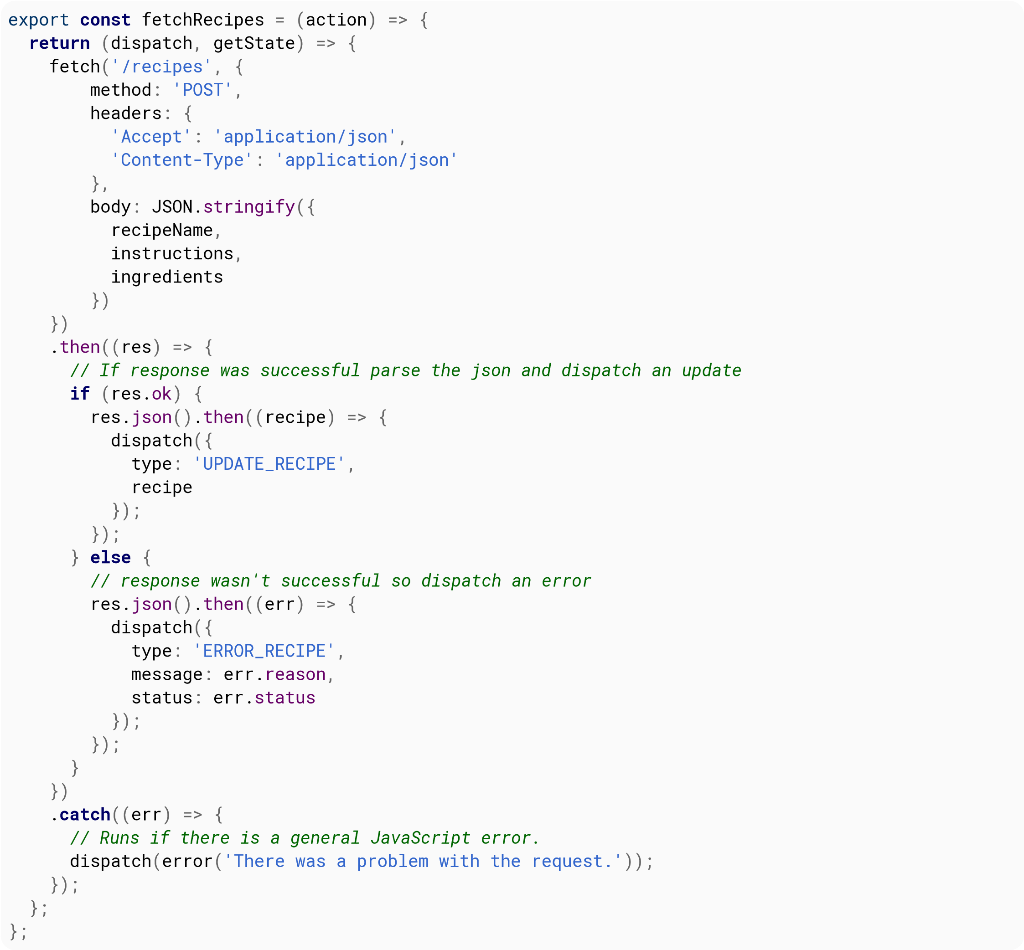

## Section 15.2: HTTP with the fetch API

It should be noted that Fetch *does not support progress callbacks*. See: <https://github.com/github/fetch/issues/89>.

The alternative is to use XMLHttpRequest <https://developer.mozilla.org/en-US/docs/Web/Events/progress>.

fetch

(

'https://mywebsite.com/mydata.json'

)

.

then

(

json

=>

console.

log

(

json

)

)

;

fetch

(

'/login'

,

{

method

:

'POST'

,

body

:

form

,

mode

:

'cors'

,

cache

:

'default'

,

}

)

.

then

(

session

=>

onLogin

(

session

)

,

failure

=>

console.

error

(

failure

)

)

;

More details about fetch can be found at [MDN](https://developer.mozilla.org/en-US/docs/Web/API/Fetch_API/Using_Fetch)

## Section 15.3: Networking with XMLHttpRequest

**var**

request

=

**new**

XMLHttpRequest

(

)

;

request.

onreadystatechange

=

(

e

)

=>

{

**if**

(

request.

readyState

!==

4

)

{

**return**

;

}

**if**

(

request.

status

===

200

)

{

console.

log

(

'success'

,

request.

responseText

)

;

}

**else**

{

console.

warn

(

'error'

)

;

}

}

;

request.

open

(

'GET'

,

'https://mywebsite.com/endpoint/'

)

;

request.

send

(

)

;

## Section 15.4: WebSockets

**var**

ws

=

**new**

WebSocket

(

'ws://host.com/path'

)

;

ws.

onopen

=

(

)

=>

{

*// connection opened*

ws.

send

(

'something'

)

;

*// send a message*

}

;

ws.

onmessage

=

(

e

)

=>

{

*// a message was received*

console.

log

(

e.

data

)

;

}

;

ws.

onerror

=

(

e

)

=>

{

*// an error occurred*

console.

log

(

e.

message

)

;

}

;

ws.

onclose

=

(

e

)

=>

{

*// connection closed*

console.

log

(

e.

code

,

e.

reason

)

;

}

;

## Section 15.5: Http with axios

**Configure**

For web request you can also use library [axios](https://github.com/mzabriskie/axios).

It's easy to configure. For this purpose you can create file axios.js for example:

import

*

as axios from

'axios'

;

**var**

instance

=

axios.

create

(

)

;

instance.

defaults

.

baseURL

=

serverURL

;

instance.

defaults

.

timeout

=

20000

;

]

*//...*

*//and other options*

export

{

instance as

**default**

}

;

and then use it in any file you want.

**Requests**

To avoid using pattern 'Swiss knife' for every service on your backend you can create separate file with methods for this within folder for integration functionality:

import

axios from

'../axios'

;

import

{

errorHandling

}

from

'../common'

;

**const**

UserService

=

{

getCallToAction

(

)

{

**return**

axios.

**get**

(

'api/user/dosomething'

)

.

then

(

response

=>

response.

data

)

.

**catch**

(

errorHandling

)

;

}

,

}

export

**default**

UserService

;

**Testing**

There is a special lib for testing axios: [axios-mock-adapter](https://github.com/ctimmerm/axios-mock-adapter).

With this lib you can set to axios any responce you want for testing it. Also you can configure some special errors for your axois'es methods. You can add it to your axios.js file created in prevous step:

import

MockAdapter from

'axios-mock-adapter'

;

**var**

mock

=

**new**

MockAdapter

(

instance

)

;

mock.

onAny

(

)

.

reply

(

500

)

;

for example.

**Redux Store**

Sometimes you need to add to headers authorize token, that you probably store in your redux store.

In this case you'll need another file, interceptors.js with this function:

export

**function**

getAuthToken

(

storeContainer

)

{

**return**

config

=>

{

**let**

store

=

storeContainer.

getState

(

)

;

config.

headers

[

'Authorization'

]

=

store.

user

.

accessToken

;

**return**

config

;

}

;

}

Next in constructor of your root component you can add this:

axios.

interceptors

.

request

.

use

(

getAuthToken

(

**this**

.

state

.

store

)

)

;

and then all your requests will be followed with your authorization token.

As you can see axios is very simple, configurable and useful library for applications based on react-native.

## Section 15.6: Web Socket with Socket.io

Install *socket.io-client*

npm i socket.io-client

--

save

Import module

import

SocketIOClient from

'socket.io-client/dist/socket.io.js'

Initialize in your constructor

constructor

(

props

)

{

super

(

props

)

;

**this**

.

socket

=

SocketIOClient

(

'http://server:3000'

)

;

}

Now in order to use your socket connection properly, you should bind your functions in constructor too. Let's assume that we have to build a simple application, which will send a ping to a server via socket after every 5 seconds (consider this as ping), and then the application will get a reply from the server. To do so, let's first create these two functions:

_sendPing

(

)

{

*//emit a dong message to socket server*

socket.

emit

(

'ding'

)

;

}

_getReply

(

data

)

{

*//get reply from socket server, log it to console*

console.

log

(

'Reply from server:'

+

data

)

;

}

Now, we need to bind these two functions in our constructor:

constructor

(

props

)

{

super

(

props

)

;

**this**

.

socket

=

SocketIOClient

(

'http://server:3000'

)

;

*//bind the functions*

**this**

._sendPing

=

**this**

._sendPing.

bind

(

**this**

)

;

**this**

._getReply

=

**this**

._getReply.

bind

(

**this**

)

;

}

After that, we also need to link _getReply function with the socket in order to receive the message from the socket server. To do this we need to attach our _getReply function with socket object. Add the following line to our constructor:

**this**

.

socket

.

on

(

'dong'

,

**this**

._getReply

)

;

Now, whenever socket server emits with the 'dong' your application will able to receive it.

# Chapter 16: Platform Module

## Section 16.1: Find the OS Type/Version

The first step is to import Platform from the 'react-native' package like so:

import

{

Platform

}

from

'react-native'

|  |
| --- |
| Platform.OS |

After you've done that, you can go ahead and access the OS type through allowing you to use it in conditional statements like

**const**

styles

=

StyleSheet.

create

(

{

height

:

(

Platform.

OS

===

'ios'

)

?

200

:

100

,

}

)

|  |
| --- |
| Platform.Version |

If you want to detect the Android version, you can use like so:

**if**

(

Platform.

Version

===

21

)

{

console.

log

(

'Running on Lollipop!'

)

;

}

For iOS, Platform.Version is returning a String, for complex condition don't forget to parse it.

**if**

(

parseInt

(

Platform.

Version

,

10

)

>=

9

)

{

console.

log

(

'Running version higher than 8'

)

;

}

If the platform specific logic is complex, one can render two different files based on platform. Ex:

|  |  |  |  |  |
| --- | --- | --- | --- | --- |
|  | |  |  |  | | --- | --- | --- | | MyTask.android | . | js | |
| |  |  |  | | --- | --- | --- | | MyTask.ios | . | js | |

and require it using

**const**

MyTask

=

require

(

'./MyTask'

)

# Chapter 17: Images

## Section 17.1: Image Module

|  |
| --- |
| react-native |

You're going to have to import Image from the package like so then use it:

import

{

Image

}

from

'react'

;

<

Image source

=

{

{

uri

:

'https://image-souce.com/awesomeImage'

}

}

/>

You can also use a local image with a slightly different syntax but same logic like so:

import

{

Image

}

from

'react'

;

<

Image source

=

{

require

(

'./img/myCoolImage.png'

)

}

/>

Note: You should give height, width to the image otherwise it won't show.

## Section 17.2: Image Example

class

ImageExample

extends

Component

{

render

(

)

{

**return**

(

<

View

>

<

Image style

=

{

{

width

:

30

,

height

:

30

}

}

source

=

{

{

uri

:

'http://facebook.github.io/react/img/logo_og.png'

}

}

/>

<

/

View

>

)

;

}

}

## Section 17.3: Conditional Image Source

**<**

**Image**

style

=

{

[

this.props.imageStyle

]

}

source

=

{

this.props.imagePath

? this.props.imagePath

: require

(

'../theme/images/resource.png'

)

}

**/>**

If the path is available in imagePath then it will be assigned to source else the default image path will be assigned.

## Section 17.4: Using variable for image path

**let**

imagePath

=

require

(

"../../assets/list.png"

)

;

<

Image style

=

{

{

height

:

50

,

width

:

50

}

}

source

=

{

imagePath

}

/>

From external resource:

**<Image** style={{height: 50, width: 50}} source={{uri: userData.image}} **/>**

## Section 17.5: To fit an Image

**<**

**Image**

resizeMode

=

"contain"

style

=

{

{

height: 100, width: 100

}

}

source

=

{

require

(

'../assets/image.png'

)

}

**/>**

Try also **cover**, **stretch**, **repeat** and **center** parameters.

# Chapter 18: Custom Fonts

## Section 18.1: Custom fonts for both Android and IOS

Create a folder in your project folder, and add your fonts to it. Example:

Example: Here we added a folder in root called "mystuff", then "fonts", and inside it we placed our fonts:

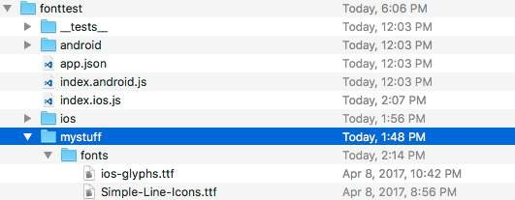

Add the below code in

package.

json

.

Using custom fonts on project below code

{

... "rnpm": { "assets": [ "path/to/fontfolder" ] }, ...

}

For the example above, our package.json would now have a path of "mystuff/fonts":

"rnpm"

:

{

"assets"

:

[

"mystuff/fonts"

]

}

Run

react

-

native

link

command.

<Text style={{ fontFamily: 'FONT-NAME' }}> My Text </Text>

|  |  |  |
| --- | --- | --- |
| FONT | - | NAME |

Where is the prefix platform specific.

**Android**

|  |  |  |
| --- | --- | --- |
| Roboto | - | Regular.ttf |

|  |  |  |  |  |
| --- | --- | --- | --- | --- |
| fontFamily | : | Roboto | - | Regular |

FONT-NAME is the words before the extension in file. Example: Your font's file name is , so you would set .

**iOS**

FONT-NAME is "Full Name" found after right clicking, on the font file, then clicking on "Get Info". ( Source:

<https://stackoverflow.com/a/16788493/2529614> ), in the screenshot below, the file name is MM Proxima Nova

|  |  |  |
| --- | --- | --- |
| Ultra bold.otf | , however "Full Name" is "Proxima Nova Semibold", thus you would set | fontFamily |

:

Proxima Nova Semibold. Screenshot -

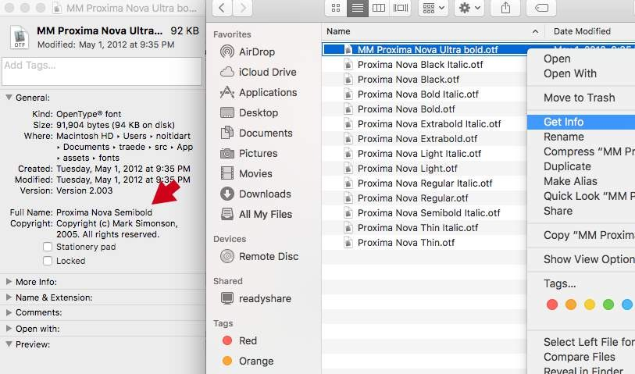

Run

react

-

native

run

-

ios

or

react

-

native

run

-

android

again (this will recompile with the resources)

## Section 18.2: Steps to use custom fonts in React Native (Android)

|  |
| --- |
| android/app/src/main/assets/fonts/font_name.ttf |

1. Paste your fonts file inside

|  |
| --- |
| react-native run-android |

1. Recompile the Android app by running

|  |
| --- |
| fontFamily: 'font_name' |

1. Now, You can use in your React Native Styles

## Section 18.3: Steps to use custom fonts in React Native (iOS)

1. **Include the font in your Xcode project.**

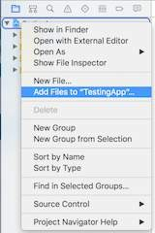

1. **Make sure that they are included in the Target Membership column**

Click on the font from the navigator, and check if the font included.

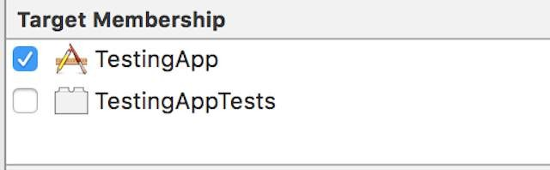

1. **Check if the font included as Resource in your bundle**click on your Xcode project file, select "Build Phases, select "Copy Bundle Resources". Check if your font is added.

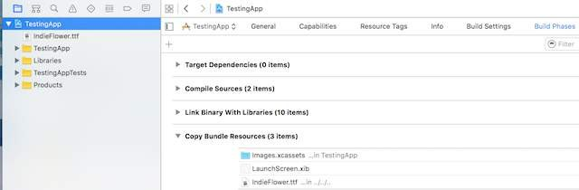

1. **Include the font in Application Plist (Info.plist)**

from the application main folder open Info.plist, click on "Information Property List", and then click the plus sign (+). from drop down list choose "Fonts provided by application".

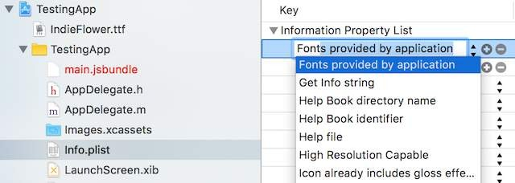

1. **Add Font name in Fonts provided by application**expand Fonts Provided by Application and add the Font Name exactly to value column

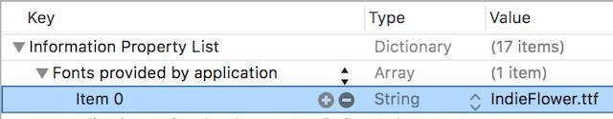

1. Use it in the Application

**<**

**Text**

style

=

{

{

fontFamily:

'IndieFlower'

}

}

**>**

Welcome to React Native!

**<**

**/Text**

**>**

# Chapter 19: Animation API

## Section 19.1: Animate an Image

class

AnimatedImage

extends

Component

{

constructor

(

props

)

{

super

(

props

)

**this**

.

state

=

{

logoMarginTop

:

**new**

Animated.

Value

(

200

)

}

}

componentDidMount

(

)

{

Animated.

timing

(

**this**

.

state

.

logoMarginTop

,

{

toValue

:

100

}

)

.

start

(

)

}

render

(

)

{

**return**

(

<

View

>

<

Animated.

Image

source

=

{

require

(

'../images/Logo.png'

)

}

style

=

{

[

baseStyles.

logo

,

{

marginTop

:

**this**

.

state

.

logoMarginTop

}

]

}

/>

<

/

View

>

)

}

}

This example is animating the image position by changing the margin.

# Chapter 20: Android - Hardware Back Button

## Section 20.1: Detect Hardware back button presses in Android

BackAndroid.

addEventListener

(

'hardwareBackPress'

,

**function**

(

)

{

**if**

(

!

**this**

.

onMainScreen

(

)

)

{

**this**

.

goBack

(

)

;

**return**

**true**

;

}

**return**

**false**

;

}

)

;

|  |  |  |
| --- | --- | --- |
| **this**.onMainScreen() | and | **this**.goBack() |

Note: are not built in functions, you also need to implement those.

(<https://github.com/immidi/react-native/commit/ed7e0fb31d842c63e8b8dc77ce795fac86e0f712)>

## Section 20.2: Example of BackAndroid along with Navigator

This is an example on how to use React Native's BackAndroid along with the Navigator.

componentWillMount registers an event listener to handle the taps on the back button. It checks if there is another view in the history stack, and if there is one, it goes back -otherwise it keeps the default behaviour.

More information on the [BackAndroid docs](https://facebook.github.io/react-native/docs/backandroid.html) and the [Navigator docs](https://facebook.github.io/react-native/docs/navigator.html).

import

React

,

{

Component

}

from

'react'

;

*// eslint-disable-line no-unused-vars*

import

{

BackAndroid

,

Navigator

,

}

from

'react-native'

;

import

SceneContainer from

'./Navigation/SceneContainer'

;

import

RouteMapper from

'./Navigation/RouteMapper'

;

export

**default**

class

AppContainer

extends

Component

{

constructor

(

props

)

{

super

(

props

)

;

**this**

.

navigator

;

}

componentWillMount

(

)

{

BackAndroid.

addEventListener

(

'hardwareBackPress'

,

(

)

=>

{

**if**

(

**this**

.

navigator

&&

**this**

.

navigator

.

getCurrentRoutes

(

)

.

length

>

1

)

{

**this**

.

navigator

.

pop

(

)

;

**return**

**true**

;

}

**return**

**false**

;

}

)

;

}

renderScene

(

route

,

navigator

)

{

**this**

.

navigator

=

navigator

;

**return**

(

<

SceneContainer

title

=

{

route.

title

}

route

=

{

route

}

navigator

=

{

navigator

}

onBack

=

{

(

)

=>

{

**if**

(

route.

index

>

0

)

{

navigator.

pop

(

)

;

}

}

}

{

...

**this**

.

props

}

/>

)

;

}

render

(

)

{

**return**

(

<

Navigator

initialRoute

=

{

<

View

/>

}

renderScene

=

{

**this**

.

renderScene

.

bind

(

**this**

)

}

navigationBar

=

{

<

Navigator.

NavigationBar

style

=

{

{

backgroundColor

:

'gray'

}

}

routeMapper

=

{

RouteMapper

}

/>

}

/>

)

;

}

}

;

## Section 20.3: Hardware back button handling using BackHandler and Navigation Properties (without using

### deprecated BackAndroid & deprecated Navigator)

This example will show you back navigation which is expected generally in most of the flows. You will have to add following code to every screen depending on expected behavior. There are 2 cases:

1. If there are more than 1 screen on stack, device back button will show previous screen.
2. If there is only 1 screen on stack, device back button will exit app.

Case 1: Show previous screen

import

{

BackHandler

}

from

'react-native'

;

constructor

(

props

)

{

super

(

props

)

**this**

.

handleBackButtonClick

=

**this**

.

handleBackButtonClick

.

bind

(

**this**

)

;

}

componentWillMount

(

)

{

BackHandler.

addEventListener

(

'hardwareBackPress'

,

**this**

.

handleBackButtonClick

)

;

}

componentWillUnmount

(

)

{

BackHandler.

removeEventListener

(

'hardwareBackPress'

,

**this**

.

handleBackButtonClick

)

;

}

handleBackButtonClick

(

)

{

**this**

.

props

.

navigation

.

goBack

(

**null**

)

;

**return**

**true**

;

}

**Important:** Don't forget to bind method in constructor and to remove listener in componentWillUnmount.

Case 2: Exit App

In this case, no need to handle anything on that screen where you want to exit app.

**Important:** This should be only screen on stack.

## Section 20.4: Example of Hardware back button detection using BackHandler

Since BackAndroid is deprecated. Use BackHandler instead of BackAndroid.

import

{

BackHandler

}

from

'react-native'

;

{

...

}

ComponentWillMount

(

)

{

BackHandler.

addEventListener

(

'hardwareBackPress'

,

(

)

=>

{

**if**

(

!

**this**

.

onMainScreen

(

)

)

{

**this**

.

goBack

(

)

;

**return**

**true**

;

}

**return**

**false**

;

}

)

;

}

# Chapter 21: Run an app on device (Android Version)

## Section 21.1: Running an app on Android Device

1. adb devices

|  |
| --- |
| adb reverse tcp:8081 tcp:8081 |

Is your phone displaying? If not, enable developer mode on your phone, and connect it by USB.

1. :

|  |
| --- |
| **Version 5** |

In order to link correctly your phone and that React-Native recognize him during build. (**NOTE:Android or above.**)

|  |
| --- |
| react-native run-android |

1. :

|  |
| --- |
| react-native start |

To run the app on your phone.

1. :

In order to start a local server for development (mandatory). This server is automatically started if you use the last version of React-native.

# Chapter 22: Native Modules

## Section 22.1: Create your Native Module (IOS)

**Introduction** from <http://facebook.github.io/react-native/docs/native-modules-ios.html>

Sometimes an app needs access to platform API, and React Native doesn't have a corresponding module yet. Maybe you want to reuse some existing Objective-C, Swift or C++ code without having to reimplement it in JavaScript, or write some high performance, multi-threaded code such as for image processing, a database, or any number of advanced extensions.

A Native Module is simply an Objective-C Class that implements the RCTBridgeModule protocol.

**Example**

|  |
| --- |
| Objective |

In your Xcode project create a new file and select **Cocoa Touch Class**, in the creation wizard choose a name for your Class (*e.g. NativeModule*), make it a **Subclass of**: NSObject and choose -C for the language.

|  |  |  |
| --- | --- | --- |
| NativeModuleEx. | h and | NativeModuleEx. |

This will create two files m

|  |  |  |
| --- | --- | --- |
| RCTBridgeModule. | h to your | NativeModuleEx. |

You will need to import h file as it follows:

#import

<

Foundation

/

Foundation.

h

>

#import

"RCTBridgeModule.h"

@

interface

NativeModuleEx

:

NSObject

<

RCTBridgeModule

>

@

end

|  |
| --- |
| NativeModuleEx. |

In your m add the following code:

#import

"NativeModuleEx.h"

@

implementation NativeModuleEx

RCT_EXPORT_MODULE

(

)

;

RCT_EXPORT_METHOD

(

testModule

:

(

NSString

*

)

string

)

{

NSLog

(

@

"The string '%@' comes from JavaScript! "

,

string

)

;

}

@

end

|  |
| --- |
| RCT_EXPORT_MODULE |

() will make your module accessible in JavaScript, you can pass it an optional argument to

specify its name. If no name is provided it will match the Objective-C class name.

|  |
| --- |
| RCT_EXPORT_METHOD |

() will expose your method to JavaScript, only the methods you export using this macro will be

accessible in JavaScript.

Finally, in your JavaScript you can call your method as it follows:

import

{

NativeModules

}

from

'react-native'

;

**var**

NativeModuleEx

=

NativeModules.

NativeModuleEx

;

NativeModuleEx.

testModule

(

'Some String !'

)

;

# Chapter 23: Linking Native API

Linking API enables you to both send and receive links between applications. For example, opening the Phone app with number dialed in or opening the Google Maps and starting a navigation to a chosen destination. You can also utilise Linking to make your app able to respond to links opening it from other applications.

|  |  |  |
| --- | --- | --- |
| react | - | native |

To use Linking you need to first import it from

|  |  |  |  |  |
| --- | --- | --- | --- | --- |
| import | { | Linking | } | from 'react-native' |

## Section 23.1: Outgoing Links

To open a link call openURL.

Linking.

openURL

(

url

)

.

**catch**

(

err

=>

console.

error

(

'An error occurred '

,

err

)

)

The preferred method is to check if any installed app can handle a given URL beforehand.

Linking.

canOpenURL

(

url

)

.

then

(

supported

=>

{

**if**

(

!

supported

)

{

console.

log

(

'Unsupported URL: '

+

url

)

}

**else**

{

**return**

Linking.

openURL

(

url

)

}

}

)

.

**catch**

(

err

=>

console.

error

(

'An error occurred '

,

err

)

)

**URI Schemes**

**Target App Example Reference**

|  |  |  |
| --- | --- | --- |
| https | : | *//stackoverflow.com* |

Web Browser

|  |  |  |  |  |  |  |
| --- | --- | --- | --- | --- | --- | --- |
| tel | :1- | 408 | - | 555 | - | 5555 |

Phone[Apple](https://developer.apple.com/library/content/featuredarticles/iPhoneURLScheme_Reference/PhoneLinks/PhoneLinks.html#//apple_ref/doc/uid/TP40007899-CH6-SW1)

|  |  |  |  |  |
| --- | --- | --- | --- | --- |
| mailto | : | email | @ | example.com |

Mail[Apple](https://developer.apple.com/library/content/featuredarticles/iPhoneURLScheme_Reference/MailLinks/MailLinks.html#//apple_ref/doc/uid/TP40007899-CH4-SW1)

|  |  |  |  |  |  |  |
| --- | --- | --- | --- | --- | --- | --- |
| sms | :1- | 408 | - | 555 | - | 1212 |

SMS[Apple](https://developer.apple.com/library/content/featuredarticles/iPhoneURLScheme_Reference/SMSLinks/SMSLinks.html#//apple_ref/doc/uid/TP40007899-CH7-SW1)

|  |  |  |
| --- | --- | --- |
| http | : | *//maps.apple.com/?ll=37.484847,-122.148386* |

|  |  |  |
| --- | --- | --- |
| geo | : | 37.7749,-122.4194 |

Apple Maps[Apple](https://developer.apple.com/library/content/featuredarticles/iPhoneURLScheme_Reference/MapLinks/MapLinks.html#//apple_ref/doc/uid/TP40007899-CH5-SW1) Google Maps[Google](https://developers.google.com/maps/documentation/android-api/intents)

iTunes See [iTunes Link Maker](https://linkmaker.itunes.apple.com/en-us) [Apple](https://developer.apple.com/library/content/featuredarticles/iPhoneURLScheme_Reference/iTunesLinks/iTunesLinks.html#//apple_ref/doc/uid/TP40007899-CH3-SW1)

|  |  |  |
| --- | --- | --- |
| fb | : | *//profile* |

Facebook[Stack Overflow](https://stackoverflow.com/questions/5707722/what-are-all-the-custom-url-schemes-supported-by-the-facebook-iphone-app)

|  |  |  |
| --- | --- | --- |
| http | : | *//www.youtube.com/v/oHg5SJYRHA0* |

|  |  |  |
| --- | --- | --- |
| facetime | : | *//user@example.com* |

YouTube[Apple](https://developer.apple.com/library/content/featuredarticles/iPhoneURLScheme_Reference/YouTubeLinks/YouTubeLinks.html#//apple_ref/doc/uid/TP40007899-CH8-SW1) Facetime[Apple](https://developer.apple.com/library/content/featuredarticles/iPhoneURLScheme_Reference/FacetimeLinks/FacetimeLinks.html#//apple_ref/doc/uid/TP40007899-CH2-SW1)

|  |  |  |
| --- | --- | --- |
| calshow | : | 514300000 |

iOS Calendar [1] [iPhoneDevWiki](http://iphonedevwiki.net/index.php/NSURL)

[1] Opens the calendar at the stated number of seconds since 1. 1. 2001 (UTC?). For some reason this API is undocumented by Apple.

## Section 23.2: Incomming Links

You can detect when your app is launched from an external URL.

componentDidMount

(

)

{

**const**

url

=

Linking.

getInitialURL

(

)

.

then

(

(

url

)

=>

{

**if**

(

url

)

{

console.

log

(

'Initial url is: '

+

url

)

}

}

)

.

**catch**

(

err

=>

console.

error

(

'An error occurred '

,

err

)

)

}

To enable this on iOS [Link RCTLinking to your project](https://facebook.github.io/react-native/docs/linking-libraries-ios.html#manual-linking).

To enable this on Android, [follow these steps](https://developer.android.com/training/app-indexing/deep-linking.html#adding-filters).

# Chapter 24: ESLint in React Native

This is the topic for ESLint rules explanation for react-native.

## Section 24.1: How to start

It's highly recommended to use ESLint in your project on react-native. ESLint is a tool for code validation using specific rules provided by community.

For react-native you can use rulesets for javascript, react and react-native.

Common ESLint rules with motivation and explanations for javascript you can find here:

<https://github.com/eslint/eslint/tree/master/docs/rules> . You can simply add ready ruleset from ESLint developers by adding in your .eslintr.json to 'extends' node 'eslint:recommended'. ( "extends": ["eslint:recommended"] ) More about ESLint configuring you can read here: <http://eslint.org/docs/developer-guide/development-environment> . It's recommended to read full doc about this extremely useful tool.

Next, full docs about rules for ES Lint react plugin you can find here:

<https://github.com/yannickcr/eslint-plugin-react/tree/master/docs/rules> . Important note: not all rules from react are relative to react-native. For example: react/display-name and react/no-unknown-property for example. Another rules are 'must have' for every project on react-native, such as react/jsx-no-bind and react/jsx-key.

Be very careful with choosing your own ruleset.

And finaly, there is a plugin explicidly for react-native: <https://github.com/intellicode/eslint-plugin-react-native> Note: If you split your styles in separate file, rule react-native/no-inline-styles will not work.

For correct working of this tool in react-native env you might need to set value or 'env' in your config to this:

"env"

:

{

"browser"

:

**true**

,

"es6"

:

**true**

,

"amd"

:

**true**

}

,

ESLint is a key tool for development of high quality product.

# Chapter 25: Integration with Firebase for Authentication

*//Replace firebase values with your app API values*

import

firebase from

'firebase'

;

componentWillMount

(

)

{

firebase.

initializeApp

(

{

apiKey

:

"yourAPIKey"

,

authDomain

:

"authDomainNAme"

,

databaseURL

:

"yourDomainBaseURL"

,

projectId

:

"yourProjectID"

,

storageBucket

:

"storageBUcketValue"

,

messagingSenderId

:

"senderIdValue"

}

)

;

firebase.

auth

(

)

.

signInWithEmailAndPassword

(

email

,

password

)

.

then

(

**this**

.

onLoginSuccess

)

}

)

}

## Section 25.1: Authentication In React Native Using Firebase

Replace firebase values with your app api values:

import

firebase from

'firebase'

;

componentWillMount

(

)

{

firebase.

initializeApp

(

{

apiKey

:

"yourAPIKey"

,

authDomain

:

"authDomainNAme"

,

databaseURL

:

"yourDomainBaseURL"

,

projectId

:

"yourProjectID"

,

storageBucket

:

"storageBUcketValue"

,

messagingSenderId

:

"senderIdValue"

}

)

;

firebase.

auth

(

)

.

signInWithEmailAndPassword

(

email

,

password

)

.

then

(

**this**

.

onLoginSuccess

)

.

**catch**

(

(

)

=>

{

firebase.

auth

(

)

.

createUserWithEmailAndPassword

(

email

,

password

)

.

then

(

**this**

.

onLoginSuccess

)

.

**catch**

(

**this**

.

onLoginFail

)

}

)

}

## Section 25.2: React Native - ListView with Firebase

This is what I do when I'm working with Firebase and I want to use ListView.

Use a parent component to retrieve the data from Firebase (Posts.js):

**Posts.js**

import

PostsList from

'./PostsList'

;

class

Posts

extends

Component

{

constructor

(

props

)

{

super

(

props

)

;

**this**

.

state

=

{

posts

:

[

]

}

}

componentWillMount

(

)

{

firebase.

database

(

)

.

ref

(

'Posts/'

)

.

on

(

'value'

,

**function**

(

data

)

{

**this**

.

setState

(

{

posts

:

data.

val

(

)

}

)

;

}

)

;

}

render

(

)

{

**return**

<

PostsList posts

=

{

**this**

.

state

.

posts

}

/>

}

}

**PostsList.js**

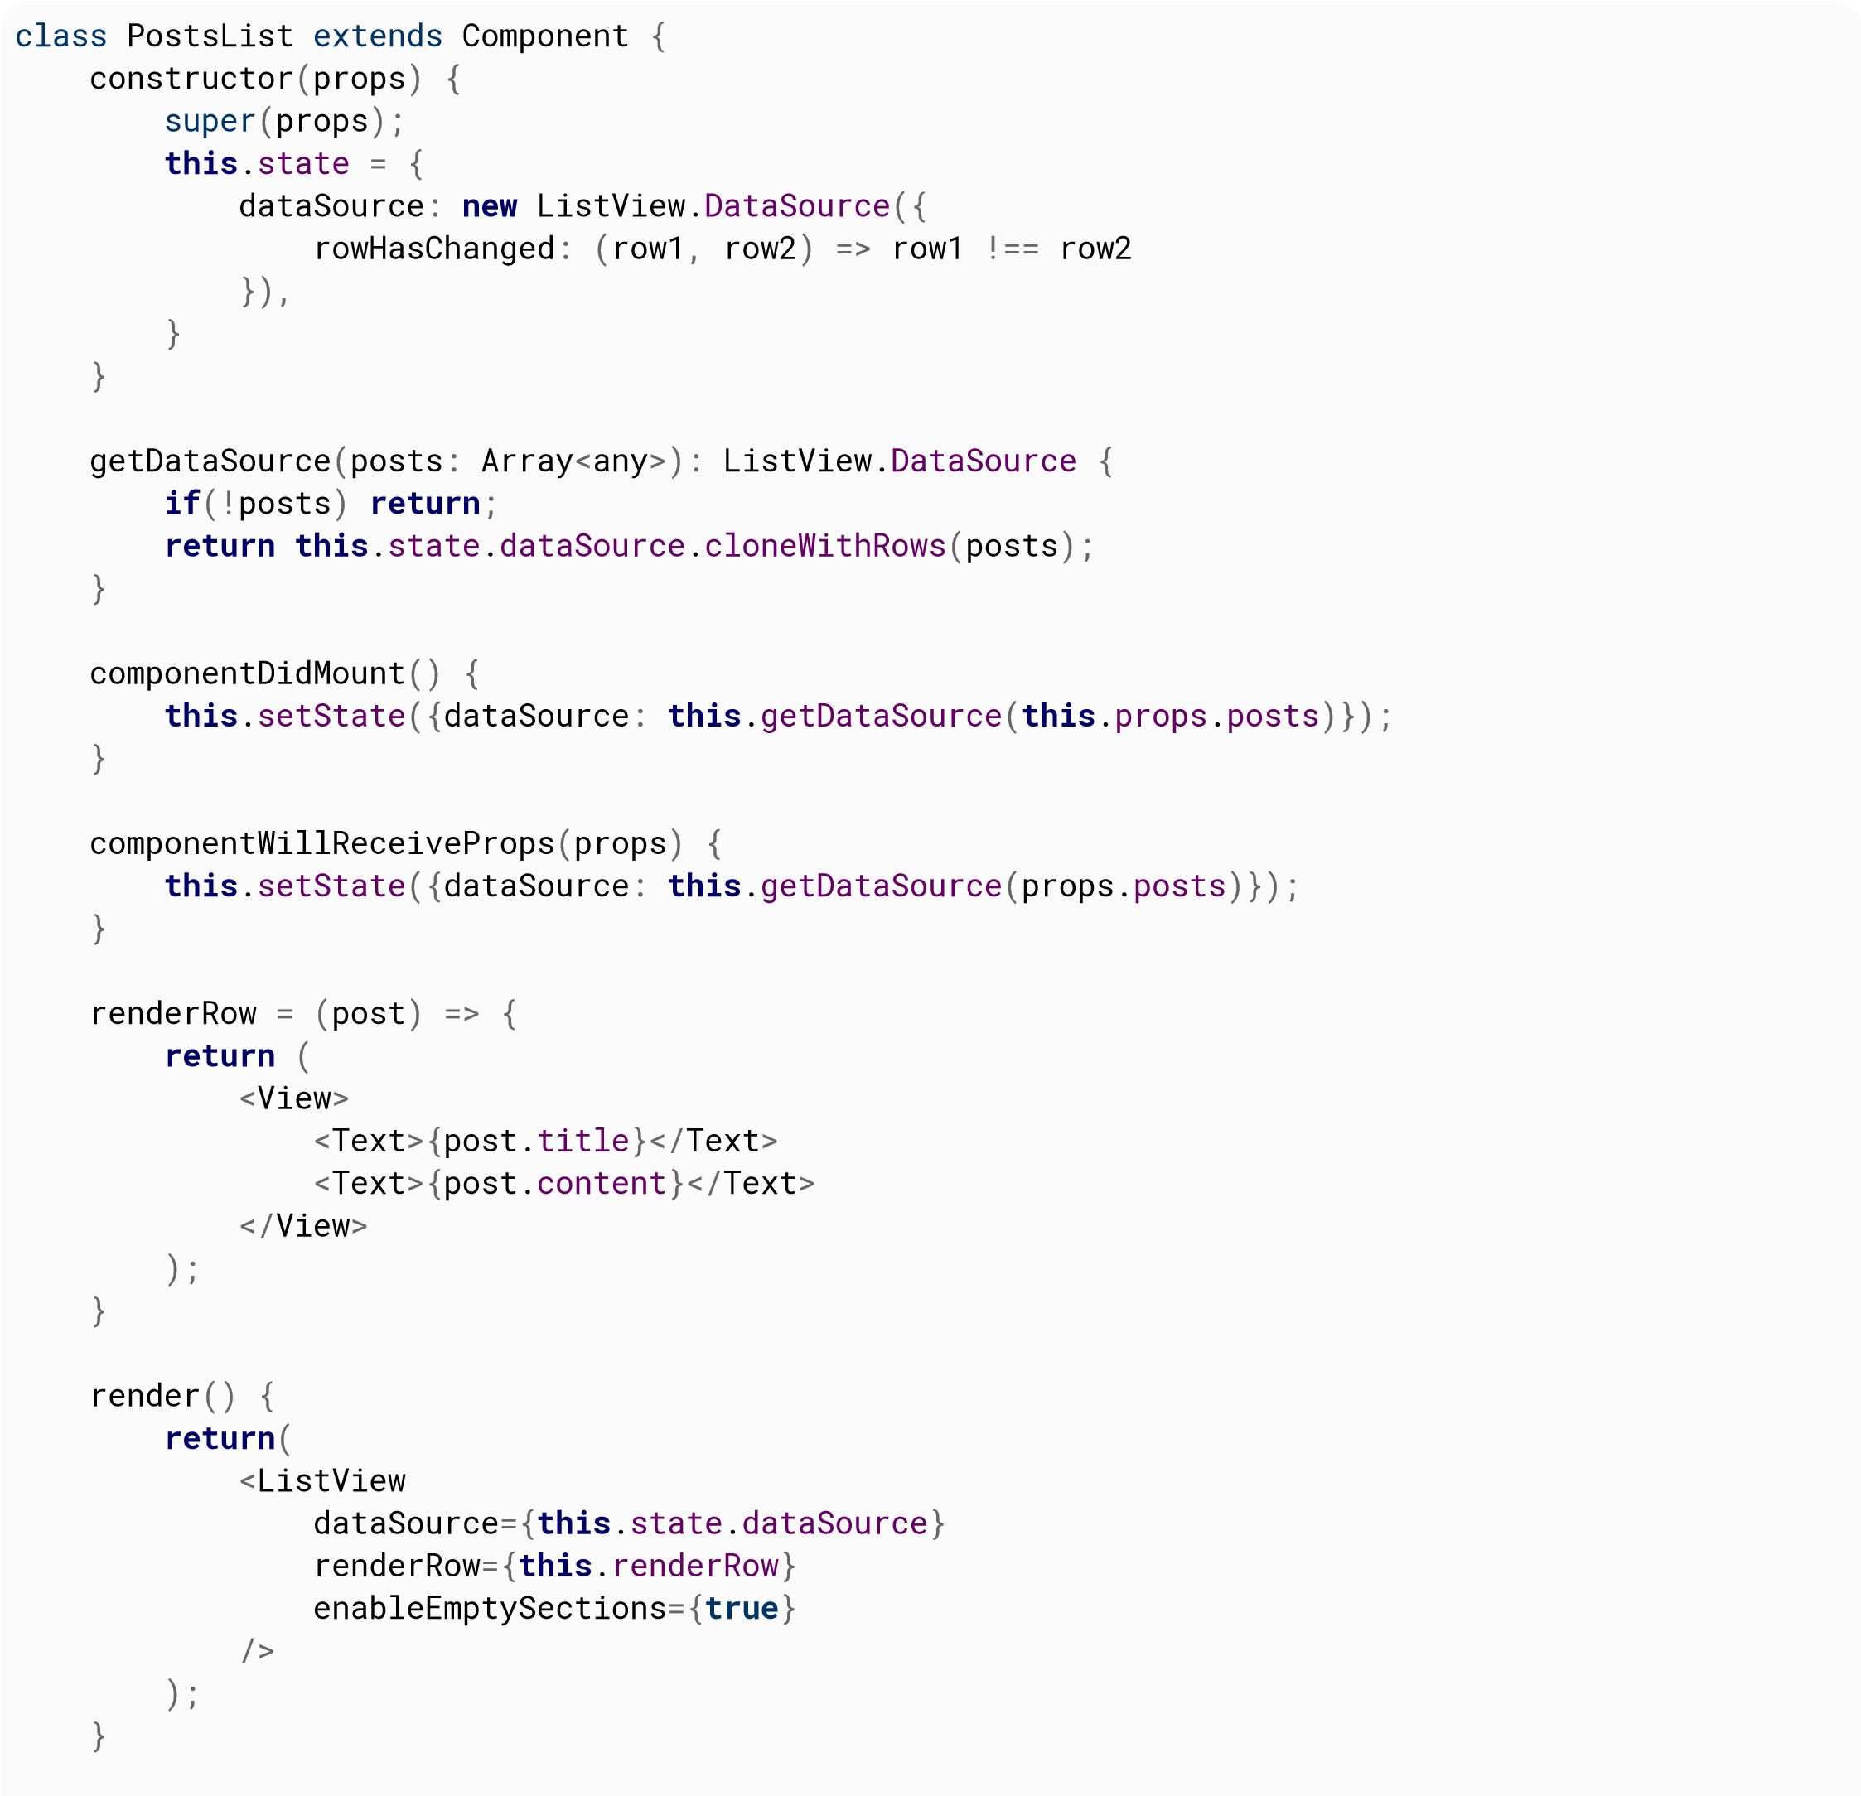

}

|  |
| --- |
| Posts.js |

I want to point out that in , I'm not importing firebase because you only need to import it once, in the main component of your project (where you have the navigator) and use it anywhere.

**This is the solution someone suggested in a question I asked when I was struggling with ListView. I thought it would be nice to share it.**

Source: [[http://stackoverflow.com/questions/38414289/react-native-listview-not-rendering-data-from-firebase][1]](http://stackoverflow.com/questions/38414289/react-native-listview-not-rendering-data-from-firebase%5D%5B1%5D)

# Chapter 26: Navigator Best Practices

## Section 26.1: Navigator

Navigator is React Native's default navigator. A Navigator component manages a *stack* of route objects, and provides methods for managing that stack.

**<**

**Navigator**

ref

=

{

(

navigator

)

=

**>**

{ this.navigator = navigator }}

initialRoute={{ id: 'route1', title: 'Route 1' }}

renderScene={this.renderScene.bind(this)}

configureScene={(route) => Navigator.SceneConfigs.FloatFromRight}

style={{ flex: 1 }}

navigationBar={

// see "Managing the Navigation Bar" below

**<**

**Navigator.NavigationBar**

routeMapper

=

{

this.routeMapper

}

**/>**

}

/>

**Managing the Route Stack**

First of all, notice the initialRoute prop. A route is simply a javascript object, and can take whatever shape you want, and have whatever values you want. It's the primary way you'll pass values and methods between components in your navigation stack.

The Navigator knows what to render based on the value returned from its renderScene prop.

renderScene

(

route

,

navigator

)

{

**if**

(

route.

id

===

'route1'

)

{

**return**

<

ExampleScene navigator

=

{

navigator

}

title

=

{

route.

title

}

/>;

*// see below*

}

**else**

**if**

(

route.

id

===

'route2'

)

{

**return**

<

ExampleScene navigator

=

{

navigator

}

title

=

{

route.

title

}

/>;

*// see below*

}

}

Let's imagine an implementation of ExampleScene in this example:

**function**

ExampleScene

(

props

)

{

**function**

forward

(

)

{

*// this route object will passed along to our `renderScene` function we defined above.*

props.

navigator

.

push

(

{

id

:

'route2'

,

title

:

'Route 2'

}

)

;

}

**function**

back

(

)

{

*// `pop` simply pops one route object off the `Navigator`'s stack*

props.

navigator

.

pop

(

)

;

}

**return**

(

<

View

>

<

Text

>

{

props.

title

}

<

/

Text

>

<

TouchableOpacity onPress

=

{

forward

}

>

<

Text

>

Go forward

!<

/

Text

>

<

/

TouchableOpacity

>

<

TouchableOpacity onPress

=

{

back

}

>

<

Text

>

Go Back

!<

/

Text

>

<

/

TouchableOpacity

>

<

/

View

>

)

;

}

**Configuring the Navigator**

You can configure the Navigator's transitions with the configureScene prop. This is a function that's passed the route object, and needs to return a configuration object. These are the available configuration objects:

Navigator.SceneConfigs.PushFromRight (default)

Navigator.SceneConfigs.FloatFromRight

Navigator.SceneConfigs.FloatFromLeft

Navigator.SceneConfigs.FloatFromBottom

Navigator.SceneConfigs.FloatFromBottomAndroid

Navigator.SceneConfigs.FadeAndroid

Navigator.SceneConfigs.HorizontalSwipeJump

Navigator.SceneConfigs.HorizontalSwipeJumpFromRight

Navigator.SceneConfigs.VerticalUpSwipeJump

Navigator.SceneConfigs.VerticalDownSwipeJump

You can return one of these objects without modification, or you can modify the configuration object to customize the navigation transitions. For example, to modify the edge hit width to more closely emulate the iOS UINavigationController's interactivePopGestureRecognizer:

configureScene

=

{

(

route

)

=>

{

**return**

{

...

Navigator

.

SceneConfigs

.

FloatFromRight

,

gestures

:

{

pop

:

{

...

Navigator

.

SceneConfigs

.

FloatFromRight

.

gestures

.

pop

,

edgeHitWidth

:

Dimensions.

**get**

(

'window'

)

.

width

/

2

,

}

,

}

,

}

;

}

}

**Managing the NavigationBar**

|  |
| --- |
| Navigator.NavigationBar |

The Navigator component comes with a navigationBar prop, which can theoretically take any properly configured React component. But the most common implementation uses the default . This takes a routeMapper prop that you can use to configure the appearance of the navigation bar based on the route.

A routeMapper is a regular javascript object with three functions: Title, RightButton, and LeftButton. For example:

**const**

routeMapper

=

{

LeftButton

(

route

,

navigator

,

index

,

navState

)

{

**if**

(

index

===

0

)

{

**return**

**null**

;

}

**return**

(

<

TouchableOpacity

onPress

=

{

(

)

=>

navigator.

pop

(

)

}

style

=

{

styles.

navBarLeftButton

}

>

<

Text

>

Back

<

/

Text

>

<

/

TouchableOpacity

>

)

;

}

,

RightButton

(

route

,

navigator

,

index

,

navState

)

{

**return**

(

<

TouchableOpacity

onPress

=

{

route.

handleRightButtonClick

}

style

=

{

styles.

navBarRightButton

}

>

<

Text

>

Next

<

/

Text

>

<

/

TouchableOpacity

>

)

;

}

,

Title

(

route

,

navigator

,

index

,

navState

)

{

**return**

(

<

Text

>

{

route.

title

}

<

/

Text

>

)

;

}

,

}

;

**See more**

For more detailed documentation of each prop, see the [the official React Native Documentation for Navigator](https://facebook.github.io/react-native/docs/navigator.html), and the React Native guide on [Using Navigators](https://facebook.github.io/react-native/docs/using-navigators.html).

## Section 26.2: Use react-navigation for navigation in react native apps

With the help of [react-navigation](https://reactnavigation.org/), you can add navigation to your app really easy. Install react-navigation

npm **install** --save react-navigation

Example:

import

{

Button

,

View

,

Text

,

AppRegistry

}

from

'react-native'

;

import

{

StackNavigator

}

from

'react-navigation'

;

**const**

App

=

StackNavigator

(

{

FirstPage

:

{

screen

:

FirstPage

}

,

SecondPage

:

{

screen

:

SecondPage

}

,

}

)

;

class

FirstPage

extends

React.

Component

{

**static**

navigationOptions

=

{

title

:

'Welcome'

,

}

;

render

(

)

{

**const**

{

navigate

}

=

**this**

.

props

.

navigation

;

**return**

(

<

Button

title

=

'Go to Second Page'

onPress

=

{

(

)

=>

navigate

(

'SecondPage'

,

{

name

:

'Awesomepankaj'

}

)

}

/>

)

;

}

}

class

SecondPage

extends

React.

Component

{

**static**

navigationOptions

=

(

{

navigation

}

)

=>

(

{

title

:

navigation.

state

.

params

.

name

,

}

)

;

render

(

)

{

**const**

{

goBack

}

=

**this**

.

props

.

navigation

;

**return**

(

<

View

>

<

Text

>

Welcome to Second Page

<

/

Text

>

<

Button

title

=

"Go back to First Page"

onPress

=

{

(

)

=>

goBack

(

)

}

/>

<

/

View

>

)

;

}

}

## Section 26.3: react-native Navigation with react-nativerouter-flux

|  |
| --- |
| npm **install** --save react-native-router-flux |

Install by using

|  |
| --- |
| **<Scene** |

In react-native-router-flux, each route is called a **>**

|  |  |  |  |  |  |  |  |  |  |  |
| --- | --- | --- | --- | --- | --- | --- | --- | --- | --- | --- |
|  | |  |  |  |  |  |  |  |  |  | | --- | --- | --- | --- | --- | --- | --- | --- | --- | | **<Scene** key | = | "home" component | ={ | LogIn | } | title | = | "Home" initial **/>** | |

key A unique string that can be used to refer to the particular scene.

component Which component to show, here it's title make a NavBar and give it a title 'Home'

initial

Is this the first screen of the App

Example:

import

React from

'react'

;

import

{

Scene

,

Router

}

from

'react-native-router-flux'

;

import

LogIn from

'./components/LogIn'

;

import

SecondPage from

'./components/SecondPage'

;

**const**

RouterComponent

=

(

)

=>

{

**return**

(

<

Router

>

<

Scene key

=

"login"

component

=

{

LogIn

}

title

=

"Login Form"

initial

/>

<

Scene key

=

"secondPage"

component

=

{

SecondPage

}

title

=

"Home"

/>

<

/

Router

>

)

;

}

;

export

**default**

RouterComponent

;

Import this file in the main App.js(index file) and render it. For more information can visit this [link](https://github.com/aksonov/react-native-router-flux/blob/master/docs/MINI_TUTORIAL.md).

# Chapter 27: Navigator with buttons injected from pages

## Section 27.1: Introduction

Instead of bloating your main js file that contains your navigator with buttons. It's cleaner to just inject buttons ondemand in any page that you need.

*//In the page "Home", I want to have the right nav button to show*

*//a settings modal that resides in "Home" component.*

componentWillMount

(

)

{

**this**

.

props

.

route

.

navbarTitle

=

"Home"

;

**this**

.

props

.

route

.

rightNavButton

=

{

text

:

"Settings"

,

onPress

:

**this**

._ShowSettingsModal.

bind

(

**this**

)

}

;

}

## Section 27.2: Full commented example

'use strict'

;

import

React

,

{

Component

}

from

'react'

;

import

ReactNative from

'react-native'

;

**const**

{

AppRegistry

,

StyleSheet

,

Text

,

View

,

Navigator

,

Alert

,

TouchableHighlight

}

=

ReactNative

;

*//This is the app container that contains the navigator stuff*

class

AppContainer

extends

Component

{

renderScene

(

route

,

navigator

)

{

**switch**

(

route.

name

)

{

**case**

"Home"

:

*//You must pass route as a prop for this trick to work properly*

**return**

<

Home route

=

{

route

}

navigator

=

{

navigator

}

{

...

route

.

passProps

}

/>

**default**

:

**return**

(

<

Text route

=

{

route

}

style

=

{

styles.

container

}

>

Your route name is probably incorrect

{

JSON.

stringify

(

route

)

}

<

/

Text

>

)

;

}

}

render

(

)

{

**return**

(

|  |
| --- |
| <Navigator navigationBar={ <Navigator.NavigationBar style={ styles.navbar } routeMapper={ NavigationBarRouteMapper } /> } initialRoute={{ name: 'Home' }} renderScene={ **this**.renderScene }  />  );  }  }  *//Nothing fancy here, except for checking for injected buttons.*  *//Notice how we are checking if there are injected buttons inside the route object. //Also, we are showing a "Back" button when the page is not at index-0 (e.g. not home)* **var** NavigationBarRouteMapper = {  LeftButton(route, navigator, index, navState) { **if**(route.leftNavButton) { **return** ( <TouchableHighlight style={styles.leftNavButton} underlayColor="transparent" onPress={route.leftNavButton.onPress}>  <Text style={styles.navbarButtonText}>{route.leftNavButton.text}</Text>  </TouchableHighlight>  ); } **else** **if**(route.enableBackButton) { **return** ( <TouchableHighlight style={styles.leftNavButton} underlayColor="transparent" onPress={() => navigator.pop() }> <Text style={styles.navbarButtonText}>Back</Text>  </TouchableHighlight>  );  }  }, RightButton(route, navigator, index, navState) { **if**(route.rightNavButton) { **return** ( <TouchableHighlight style={styles.rightNavButton} underlayColor="transparent" onPress={route.rightNavButton.onPress}> <Text style={styles.navbarButtonText}>{route.rightNavButton.text}</Text>  </TouchableHighlight>  );  }  },  Title(route, navigator, index, navState) {  *//You can inject the title aswell. If you don't we'll use the route name.*  **return** (<Text style={styles.navbarTitle}>{route.navbarTitle || route.name}</Text>); }  };    *//This is considered a sub-page that navigator is showing* class Home extends Component { |

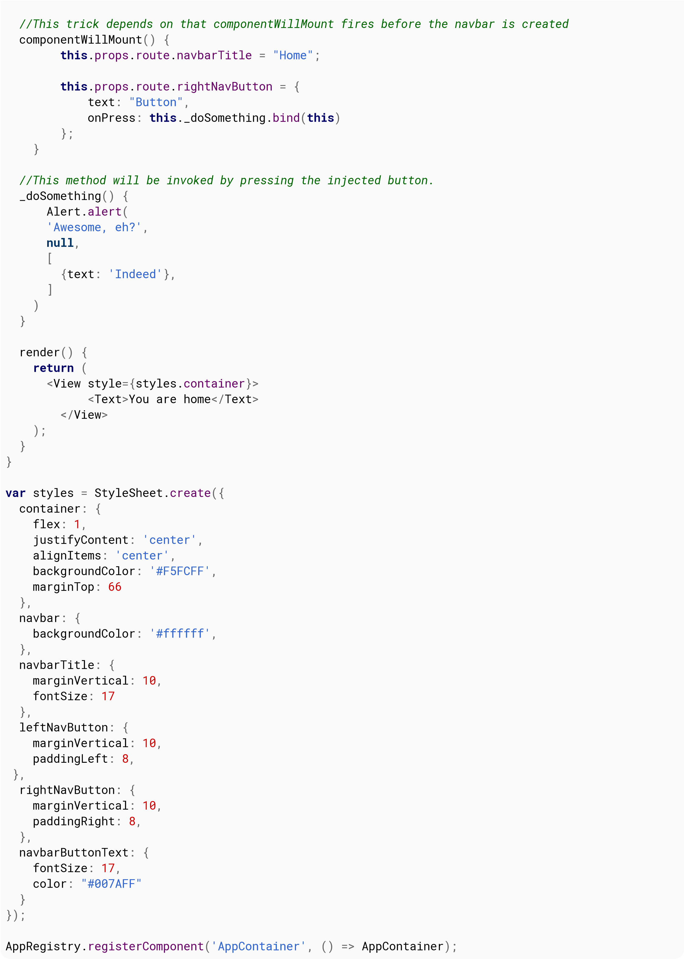

# Chapter 28: Create a shareable APK for android

Steps to create an APK (signed and unsigned) which you can install on a device using CLI and share as well:

**Problem statement:** I've built my app, I can run it on my local emulator (and also on my android device by changing debug server). But, I want to build an apk that I can send to someone without access to development server and I want them to be able to test application.

## Section 28.1: Create a key to sign the APK

keytool -genkey -v -keystore my-app-key.keystore -alias my-app-alias -keyalg RSA -keysize 2048 validity 10000

Use a password when prompted

## Section 28.2: Once the key is generated, use it to generate the installable build:

react-native bundle --platform android --dev **false** --entry-file index.android.js \

--bundle-output android/app/src/main/assets/index.android.bundle \

--assets-dest android/app/src/main/res/

## Section 28.3: Generate the build using gradle

**cd**

android

**&&**

.

**/**

gradlew assembleRelease

## Section 28.4: Upload or share the generated APK

Upload the APK to your phone. The -r flag will replace the existing app (if it exists)

adb install

-

r .

/

app

/

build

/

outputs

/

apk

/

app

-

release

-

unsigned.

apk

The shareable signed APK is located at:

.

/

app

/

build

/

outputs

/

apk

/

app

-

release.

apk

# Chapter 29: PushNotification

We can add Push Notification to react native app by using the npm module [**react-native-push-notification** by **zo0r**](https://github.com/zo0r/react-native-push-notification). This enables for a cross platform development. **Installation** *npm install --save react-native-push-notification react-native link*

## Section 29.1: Push Notification Simple Setup

Create new project PushNotification

react

-

native

init PushNotification

Put following in index.android.js

import

React

,

{

Component

}

from

'react'

;

import

{

AppRegistry

,

StyleSheet

,

Text

,

View

,

Button

}

from

'react-native'

;

import

PushNotification from

'react-native-push-notification'

;

export

**default**

class

App

extends

Component

{

constructor

(

props

)

{

super

(

props

)

;

**this**

.

NewNotification

=

**this**

.

NewNotification

.

bind

(

**this**

)

;

}

componentDidMount

(

)

{

PushNotification.

configure

(

{

*// (required) Called when a remote or local notification is opened or received*

onNotification

:

**function**

(

notification

)

{

console.

log

(

'NOTIFICATION:'

,

notification

)

;

}

,

*// Should the initial notification be popped automatically*

*// default: true*

popInitialNotification

:

**true**

,

*/\*\**

*\* (optional) default: true*

*\* - Specified if permissions (ios) and token (android and ios) will requested or not,*

*\* - if not, you must call PushNotificationsHandler.requestPermissions() later*

*\*/*

requestPermissions

:

**true**

,

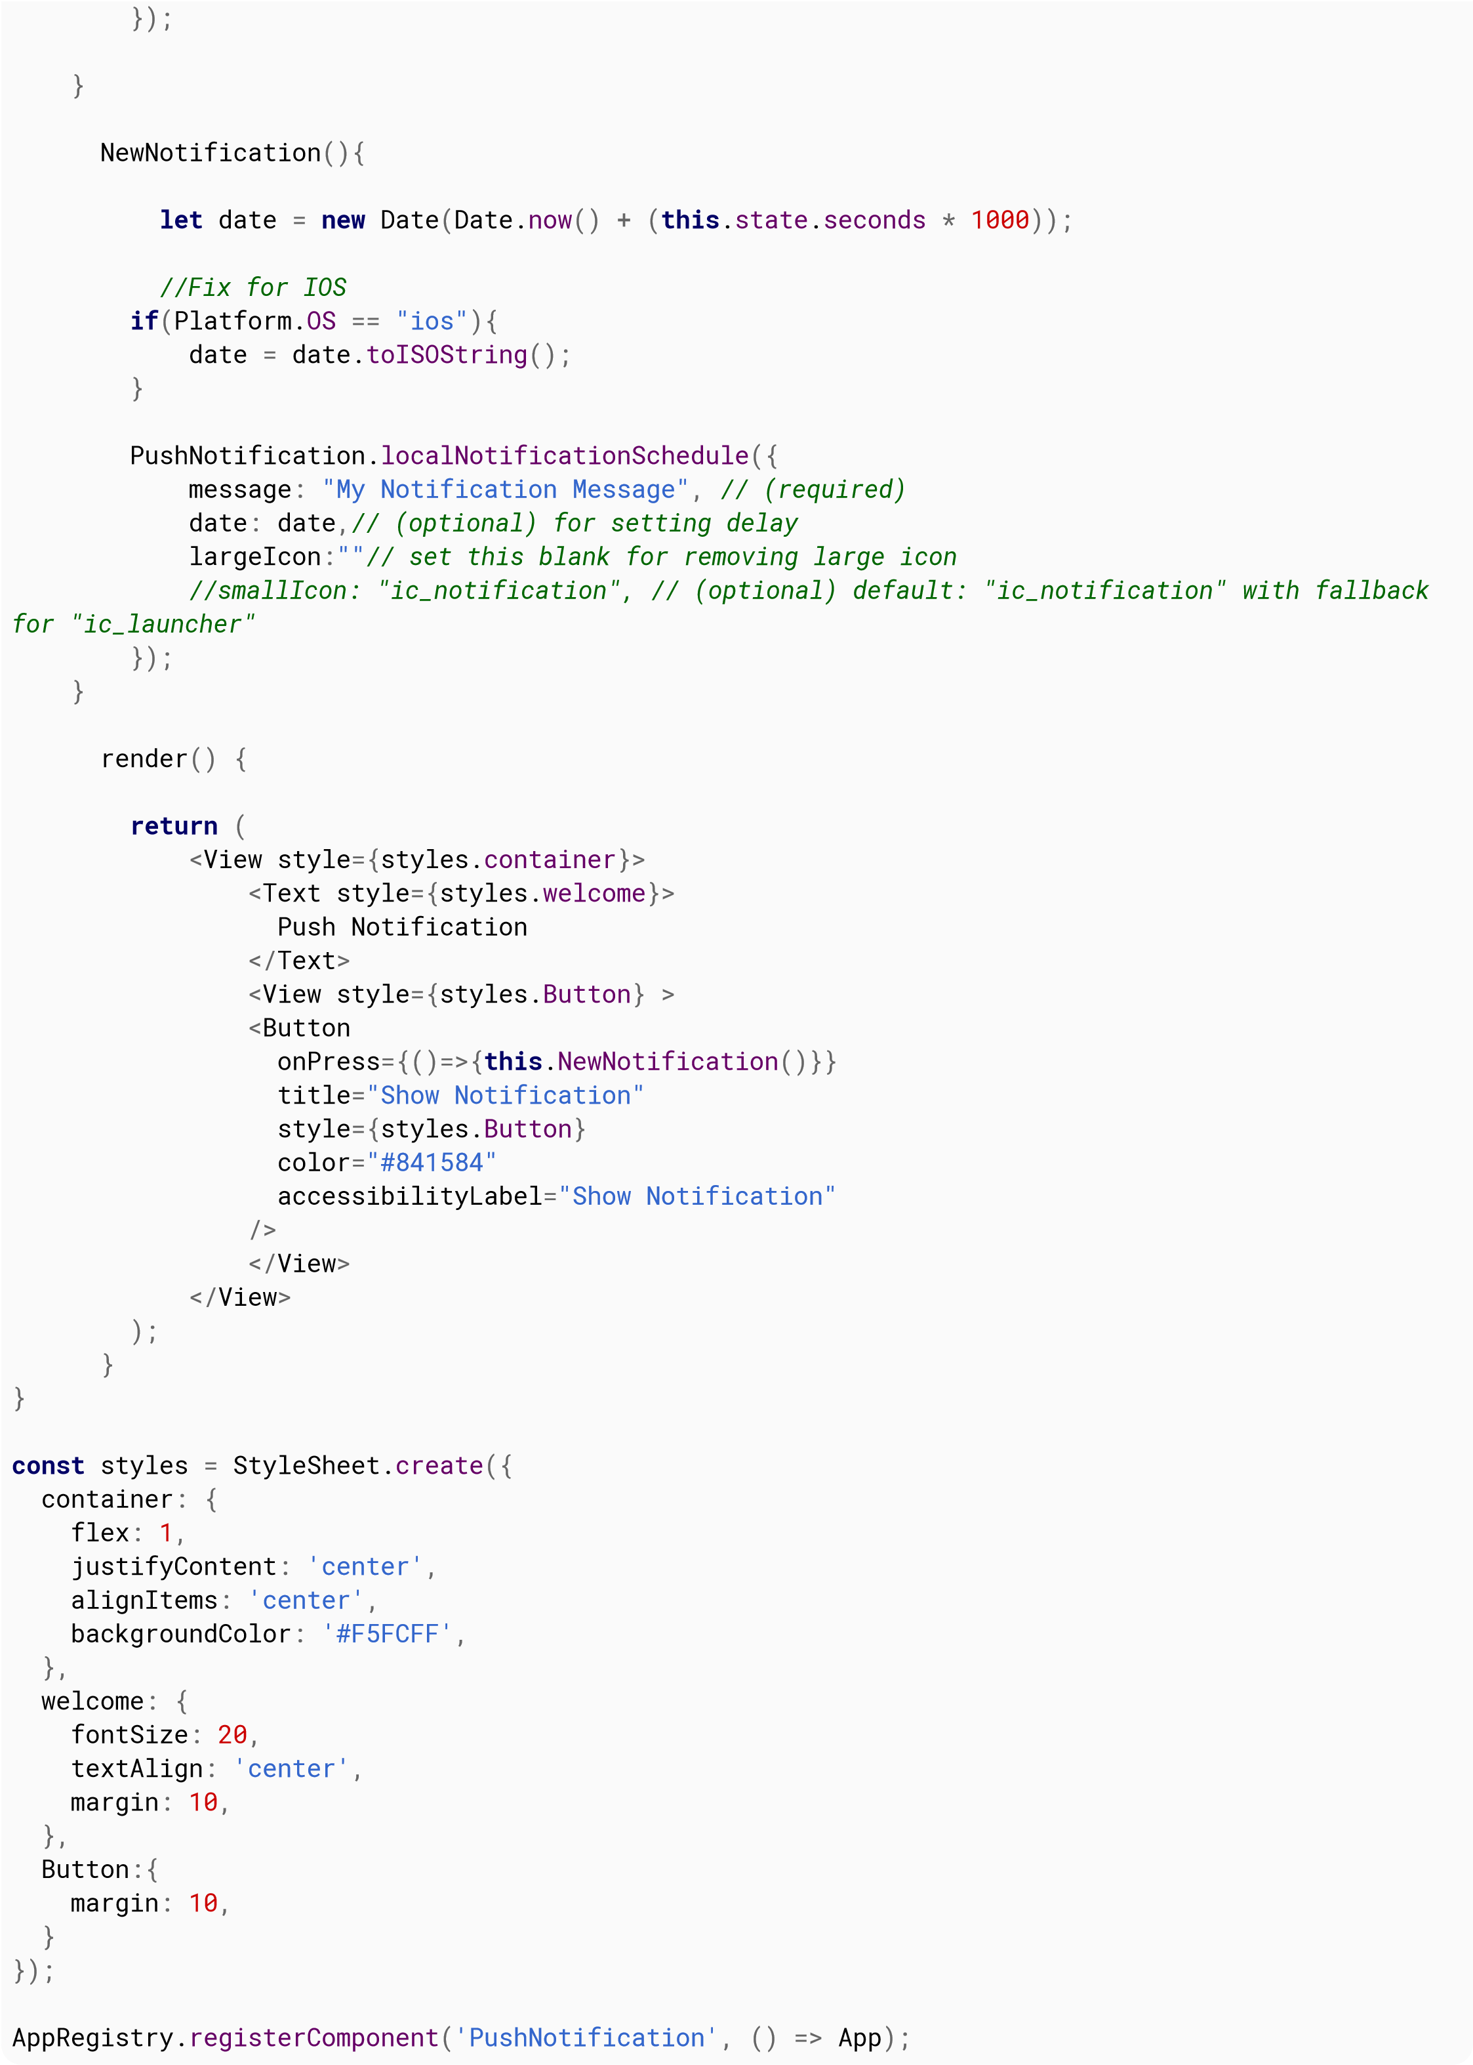

## Section 29.2: Navigating to scene from Notification

Here's a simple example to demonstrate that how can we jump/open a specific screen based on the notification. For example, when a user clicks on the notification, the app should open and directly jump to notifications page instead of home page.

'use strict'

;

import

React

,

{

Component

}

from

'react'

;

import

{

StyleSheet

,

Text

,

View

,

Navigator

,

TouchableOpacity

,

AsyncStorage

,

BackAndroid

,

Platform

,

}

from

'react-native'

;

import

PushNotification from

'react-native-push-notification'

;

**let**

initialRoute

=

{

id

:

'loginview'

}

export

**default**

class

MainClass

extends

Component

{

constructor

(

props

)

{

super

(

props

)

;

**this**

.

handleNotification

=

**this**

.

handleNotification

.

bind

(

**this**

)

;

}

handleNotification

(

notification

)

{

console.

log

(

'handleNotification'

)

;

**var**

notificationId

=

''

*//your logic to get relevant information from the notification*

*//here you navigate to a scene in your app based on the notification info*

**this**

.

navigator

.

push

(

{

id

:

Constants.

ITEM_VIEW_ID

,

item

:

item

}

)

;

}

componentDidMount

(

)

{

**var**

that

=

**this**

;

PushNotification.

configure

(

{

*// (optional) Called when Token is generated (iOS and Android)*

onRegister

:

**function**

(

token

)

{

console.

log

(

'TOKEN:'

,

token

)

;

}

,

*// (required) Called when a remote or local notification is opened or received*

onNotification

(

notification

)

{

console.

log

(

'onNotification'

)

console.

log

(

notification

)

;

that.

handleNotification

(

notification

)

;

}

,

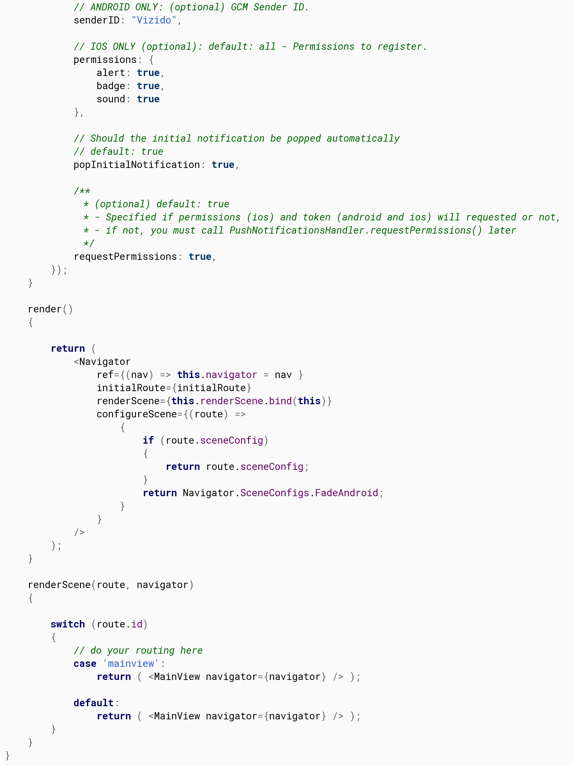

# Chapter 30: Render Best Practises

Topic for important notes about specific Component.render method behavoir.

## Section 30.1: Functions in JSX

For better performance it's important to avoid using of array (lambda) function in JSX.

As explained at <https://github.com/yannickcr/eslint-plugin-react/blob/master/docs/rules/jsx-no-bind.md> :

A bind call or arrow function in a JSX prop will create a brand new function on every single render. This is bad for performance, as it will result in the garbage collector being invoked way more than is necessary. It may also cause unnecessary re-renders if a brand new function is passed as a prop to a component that uses reference equality check on the prop to determine if it should update.

So if have jsx code block like this:

**<**

**TextInput**

onChangeValue

=

{

value =

**>**

this.handleValueChanging(value) }

/>

or

**<button** onClick={ this.handleClick.bind(this) }**></button>** you can make it better:

**<**

**TextInput**

onChangeValue

=

{

this.handleValueChanging

}

**/>**

and

**<button** onClick={ this.handleClick }**></button>**

For correct context within handleValueChanging function you can apply it in constructor of component:

constructor

(

)

{

**this**

.

handleValueChanging

=

**this**

.

handleValueChanging

.

bind

(

**this**

)

}

more in [binding a function passed to a component](https://stackoverflow.com/questions/35446486/binding-a-function-passed-to-a-component)

Or you can use solutions like this: <https://github.com/andreypopp/autobind-decorator> and simply add @autobind decorator to each methos that you want bind to:

@

autobind

handleValueChanging

(

newValue

)

{

*//processing event*

}

# Chapter 31: Debugging

## Section 31.1: Start Remote JS Debugging in Android

You can start the remote debugging from Developer menu. After selecting the enable remote debugging it will open Google Chrome, So that you can log the output into your console. You can also write debugger syntax into your js code.

## Section 31.2: Using console.log()

|  |
| --- |
| console.log() |

You can print log message in the terminal using . To do so, open a new terminal and run following command for Android:

react

-

native

log

-

android

or following command if you are using iOS:

react

-

native

log

-

ios

You will now start to see all the log message in this terminal

# Chapter 32: Unit Testing

Unit testing is a low level testing practice where smallest units or components of the code are tested.

## Section 32.1: Unit Test In React Native Using Jest

Starting from react-native version 0.38, a Jest setup is included by default when running react-native init. The following configuration should be automatically added to your package.json file:

"scripts"

:

{

"start"

:

"node node_modules/react-native/local-cli/cli.js start"

,

"test"

:

"jest"

}

,

"jest"

:

{

"preset"

:

"react-native"

}

|  |
| --- |
| run npm **test** or jest |

You can run to test in react native. For code example: [Link](https://github.com/facebook/jest/tree/master/examples/react-native)

# Credits

Thank you greatly to all the people from Stack Overflow Documentation who helped provide this content, more changes can be sent to web@petercv.com for new content to be published or updated

|  |  |
| --- | --- |
| [Abdulaziz Alkharashi](https://stackoverflow.com/users/5518977/) | Chapters 12 and 18 |
| [Aditya Singh](https://stackoverflow.com/users/3878940/) | Chapter 28 |
| [Ahmed Al Haddad](https://stackoverflow.com/users/579497/) | Chapter 27 |
| [Ahmed Ali](https://stackoverflow.com/users/529524/) | Chapter 5 |
| [Alex Belets](https://stackoverflow.com/users/6007731/) | Chapters 9, 15, 24 and 30 |
| [Alireza Valizade](https://stackoverflow.com/users/5738822/) | Chapter 15 |
| [Andres C. Viesca](https://stackoverflow.com/users/4655076/) | Chapter 22 |
| [Ankit Sinha](https://stackoverflow.com/users/5097161/) | Chapters 25, 26 and 32 |
| [AntonB](https://stackoverflow.com/users/2920441/) | Chapter 15 |
| [Cássio Santos](https://stackoverflow.com/users/5960453/) | Chapter 20 |
| [CallMeNorm](https://stackoverflow.com/users/1437652/) | Chapter 3 |
| [Chris Pena](https://stackoverflow.com/users/2903590/) | Chapters 3 and 15 |
| [corasan](https://stackoverflow.com/users/4980591/) | Chapter 25 |
| [Daniel Schmidt](https://stackoverflow.com/users/1559386/) | Chapter 15 |
| [David](https://stackoverflow.com/users/457407/) | Chapter 6 |
| [Dmitry Petukhov](https://stackoverflow.com/users/4569475/) | Chapters 1, 14 and 15 |
| [Dr. Nitpick](https://stackoverflow.com/users/6526330/) | Chapter 1 |
| [epsilondelta](https://stackoverflow.com/users/2692798/) | Chapter 14 |
| [fson](https://stackoverflow.com/users/1530110/) | Chapter 3 |
| [Gabriel Diez](https://stackoverflow.com/users/8390808/) | Chapter 16 |
| [Idan](https://stackoverflow.com/users/5099208/) | Chapters 3 and 14 |
| [Jagadish Upadhyay](https://stackoverflow.com/users/4700360/) | Chapters 3, 6, 9, 14, 15, 16, 17 and 31 |
| [Jigar Shah](https://stackoverflow.com/users/6592263/) | Chapters 4, 8 and 17 |
| [Kaleb Portillo](https://stackoverflow.com/users/4473974/) | Chapters 1 and 11 |
| [Liron Yahdav](https://stackoverflow.com/users/62/) | Chapter 5 |
| [Lucas Oliveira](https://stackoverflow.com/users/5668696/) | Chapter 1 |
| [Lwin Kyaw Myat](https://stackoverflow.com/users/2955679/) | Chapters 18 and 21 |
| [manosim](https://stackoverflow.com/users/1460144/) | Chapters 1, 14 and 20 |
| [Mayeul](https://stackoverflow.com/users/6209091/) | Chapter 21 |
| [Michael Hancock](https://stackoverflow.com/users/6306281/) | Chapter 10 |
| [Michael Helvey](https://stackoverflow.com/users/4468277/) | Chapter 26 |
| [Michael S](https://stackoverflow.com/users/4904320/) | Chapter 20 |
| [mostafiz rahman](https://stackoverflow.com/users/1067326/) | Chapter 31 |
| [Mozak](https://stackoverflow.com/users/1258489/) | Chapter 14 |
| [Noitidart](https://stackoverflow.com/users/1828637/) | Chapter 18 |
| [Pankaj Thakur](https://stackoverflow.com/users/5439331/) | Chapter 26 |
| [Pascal Le Merrer](https://stackoverflow.com/users/1392658/) | Chapter 20 |
| [respectTheCode](https://stackoverflow.com/users/109306/) | Chapter 15 |
| [Scimonster](https://stackoverflow.com/users/3187556/) | Chapters 1 and 8 |
| [Serdar Değirmenci](https://stackoverflow.com/users/1981420/) | Chapter 17 |
| [shaN](https://stackoverflow.com/users/4221558/) | Chapters 15 and 29 |
| [Sriraman](https://stackoverflow.com/users/2859018/) | Chapters 10, 14, 18, 19 and 20 |
| [stereodenis](https://stackoverflow.com/users/1418098/) | Chapter 2 |
| [sudo bangbang](https://stackoverflow.com/users/3951782/) | Chapters 7, 9, 13 and 32 |
| [Tejashwi Kalp Taru](https://stackoverflow.com/users/2520628/) | Chapters 15 and 29 |
| [Tim Rijavec](https://stackoverflow.com/users/2365792/) | Chapters 6 and 14 |
| [Tushar Khatiwada](https://stackoverflow.com/users/2649897/) | Chapter 1 |

|  |  |
| --- | --- |
| [Viktor Seč](https://stackoverflow.com/users/3804991/) | Chapter 23 |
| [Virat18](https://stackoverflow.com/users/2169736/) | Chapter 20 |
| [xhg](https://stackoverflow.com/users/2361752/) | Chapter 1 |
| [Yevhen Dubinin](https://stackoverflow.com/users/1492173/) | Chapters 1 and 3 |
| [Zakaria Ridouh](https://stackoverflow.com/users/6457567/) | Chapters 2, 16 and 17 |
| [zhenjie ruan](https://stackoverflow.com/users/4016936/) | Chapter 3 |

# You may also like

